ICM Notes Name _______________________________ Date ______________
3.3 Variance & Standard Deviation
Let X and Y denote the random variables whose values are the weights of the brand X and brand Y potato chips. Draw a histogram for each brand and find the expected value.
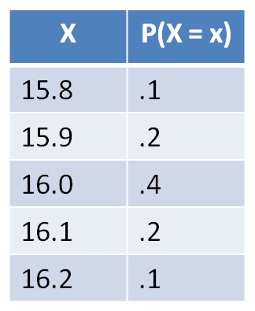
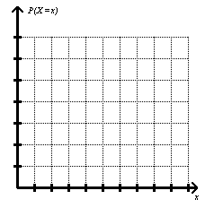
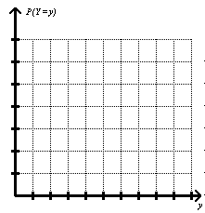
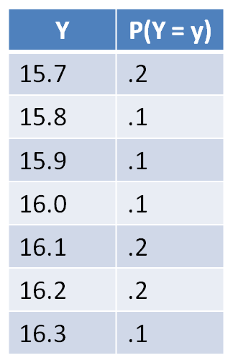

Variance is a measure of the spread of the data. The larger the variance, the larger the spread.
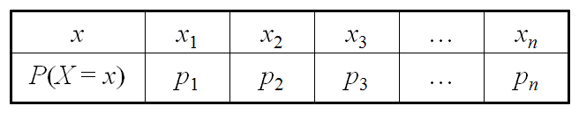
Suppose a random variable has the probability distribution

and expected value E(X) = μ, the variance is defined as:
Find the variance of the weights of brand X and brand Y potato chips.

Standard deviation is a measure of the spread of the data using the same units as the data.
The standard deviation of a random variable X is defined as:
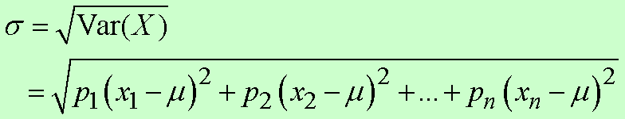
Find the standard deviation of the weight of brand X and brand Y.

To find standard deviation and mean in TI- 83/84plus:
- Type X values (values of random variable) in L1.
- Type probability distribution or frequencies in L2 (it will work for either!!)
- Then press STAT, choose CALC, 1-Var Stats, L1, L2, ENTER
x = the mean and σx = the standard deviation.
*If you are asked variance, what should you do?

