ICM – 3.5 z-scores and the Empirical Rule Name ___________________________________ Date _______________
Statistics is the practice or science of _______________________________________________________________ in large quantities,
especially for the purpose of _______________________________________ in a whole from those in a representative sample.
Symbols: | Parameter: | Statistic:
Mean

Proportion

Standard Deviation

Characteristics of a Normal Distribution:
1. _________________________________________________________
2. _________________________________________________________
3. _________________________________________________________
The Standard Normal Distribution Curve:
All normal distributions will have a bell shaped curve.
The area under the curve is 1.
50% of the data is above the mean and 50% is below the mean.
The mean is 0. (µ = 0)
The standard deviation is 1. ($σ$ = 1)

-3 -2 -1 0 1 2 3

The z-score is the number of ______________________________________________ a value is from the _____________________________.
What is the z-score of the value indicated on the curve?
1. 2. 3.
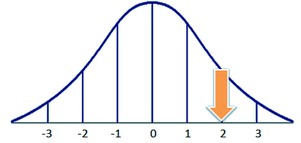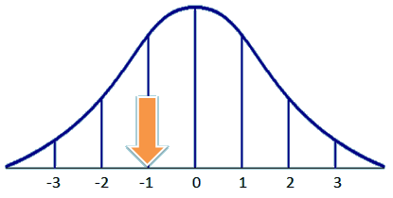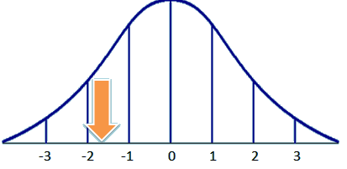
Precise formula for finding a z-score: Meaning of a positive z-score? Meaning of a negative z-score?
$z=$

In statistics, the “68–95–99.7” rule, also known as the Empirical Rule, ________________________________________
_________________________________________________________________________________________________.
______________ % falls within ± 1σ ________________% falls within ± 2σ
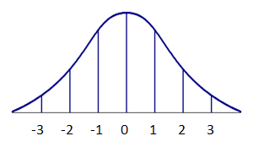
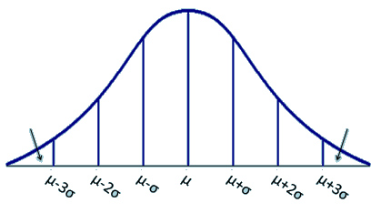
______________% falls within ± 3σ

How do we use the empirical rule? The scores on the Math III midterm were normally distributed. The mean is 82 with a standard deviation of 5. Create and label a normal distribution curve to model the scenario.
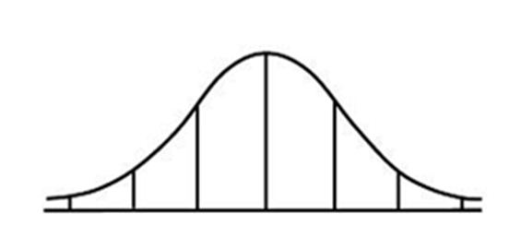
1. Find the probability that a randomly selected person:
a. scored between 77 and 87

b. scored between 82 and 87

c. scored between 72 and 87

d. scored higher than 92

e. scored less than 77

2. If 300 students took the midterm, how many scored less than 77?

