ICM 3.6 Applications of the Normal Distribution (with Technology)
Today’s Objectives:
1. ____________________________________________________________________________________________________________________________
2. ____________________________________________________________________________________________________________________________
Review: Z-Scores and Percentages:
1. The grades on a Math III midterm at WYWLA are normally distributed with μ = 74 and σ = 3.0. Dionejala scored 82 on the exam. Find the z-score for Dionejala's exam grade. Round to two decimal places.

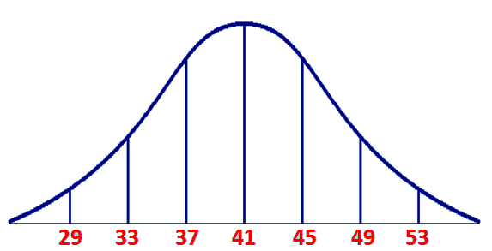
Use the diagram to answer the following questions:
2. What is the mean?

3. Standard Deviation?

4. The data is normally distributed. What percentage of the values lies between 33 and 45?

5. Assuming 200 people are involved in this data set, how many people fall between 33 and 45?
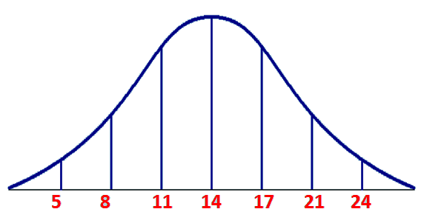

6. What is wrong with the diagram at the right?

Using Technology:
If you’re looking for probabilities that are not perfect standard deviations away from the mean, you can’t use the Empirical Rule!
Use the calculator function: How do I find it?
The scores on the Math III midterm were normally distributed. The mean is 82 with a standard deviation of 5. Draw and label a normal curve and find each probability.
a. What’s the probability that a randomly selected student scored between 80 and 90?

b. What’s the probability that a randomly selected student scored below 70?

c. What’s the probability that a randomly selected student scored above 79?

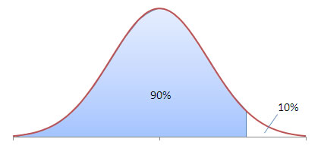
You can also work backward to find percentiles!
d. What score would a student need in order to be in the 90th percentile?

e. What score would a student need in order to be in top 20% of the class?

2. The average waiting time at Walgreen’s drive-through window is 7.6 minutes, with a standard deviation of 2.6 minutes. When a customer arrives at Walgreen’s, find the probability that he will have to wait
a) between 4 and 6 minutes

b) less than 3 minutes

c) more than 8 minutes

d) Only 8% of customers have to wait longer than Mrs. di Carlo. Determine how long Mrs. di Carlo has to wait.

