ICM – Lesson 4.1 Classwork Name ______________________________________________

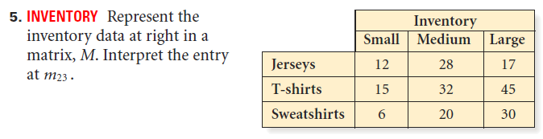

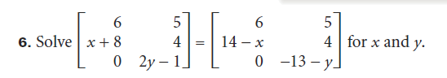

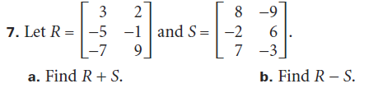

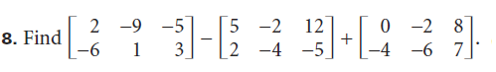



**10.**







16. 