4.5 Exercises Name _______________________________________ Date ________________

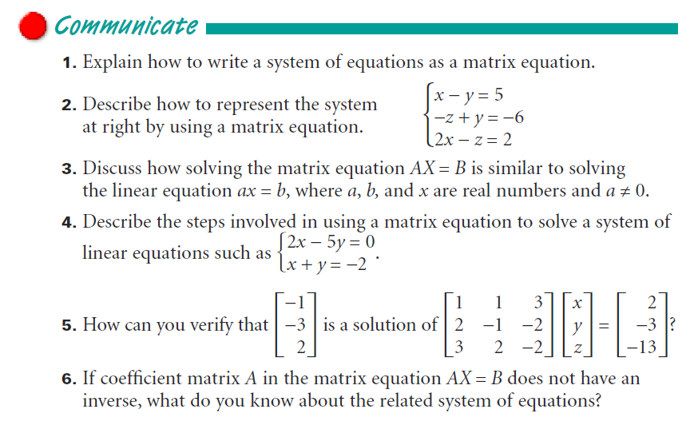

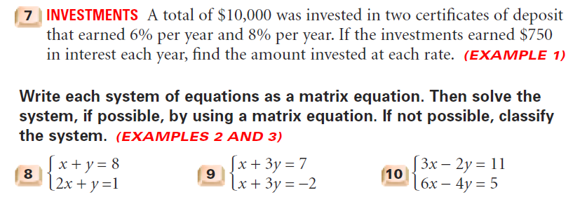

And solve!

