Name ________________________________________________ Date ________________________________

**ICM Notes – 5.6 Finding Limits Graphically & Numerically**

$$\lim_{x→c}{f\left(x\right)=L}$$

means

Note:

Examples: Evaluate each using the graphs.

1. A) B) 2. A) B)





One-sided Limits

$\lim_{x→c^{-}}{f\left(x\right)}$

$\lim_{x→c^{+}}{f\left(x\right)}$

Example

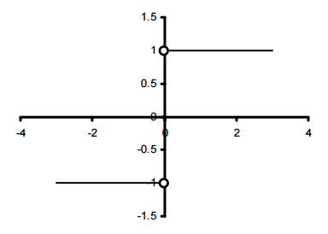3. A) $\lim_{x→0^{-}}{f\left(x\right)}$ B) $\lim_{x→0^{+}}{f\left(x\right)}$ 4. A) $\lim_{x→1^{-}}{f\left(x\right)}$ B) $\lim_{x→1^{+}}{f\left(x\right)}$

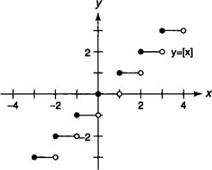

Three ways that a limit fails to exist!

1.

 Example: $\lim_{x→3}{f\left(x\right)}$

2.

Examples: $\lim_{x→0}{f\left(x\right)}$ $\lim_{x→0}{f\left(x\right)}$



3.

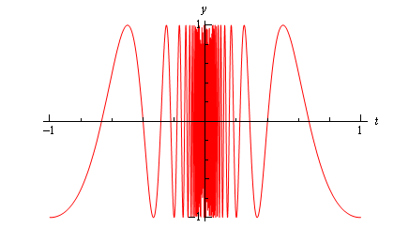 Example: $\lim_{x→0}{\cos{\frac{π}{x}}}$

**Find each Limit Using a Table:**

**2nd window for Table Setup, change indpnt to ASK**

1. $\lim_{x→2}{\frac{x^{2}-4}{x-2}}$**2. $\lim_{x→0}{\frac{\sqrt{x+5}-\sqrt{5}}{x}}$**

|  |  |
| --- | --- |
| **x** | **y** |
| 1.9 |  |
| 1.99 |  |
| 1.999 |  |
| 2.001 |  |
| 2.01 |  |
| 2.1 |  |

|  |  |
| --- | --- |
| **x** | **y** |
| -0.1 |  |
| -0.01 |  |
| -0.001 |  |
| 0.001 |  |
| 0.01 |  |
| 0.1 |  |

Table Setup – Start: c, ΔTbl: .001 Indnt: AUTO

**3. $\lim_{x→-1}{\frac{x^{2}-1}{x+1}}$ 4. $\lim_{x→0}{\frac{\left|x\right|}{x}}$**

5. $\lim_{x→\frac{π}{2}}{cos x-2}$