ICM Guided Notes Name _____________________________________ Date _________________________
6.2 The Number of Elements in a Finite Set
Notation:
Ex: 1 A = {2, 4, 6, 8} n(A) = B = {1, 2, 3, …, 30} n(B) =
Ex 2: A = {a, b, c, d, e} B = {d, e, f, g, h, i, j}
Find A $∪$ B

Find A $∩$ B

Now find each of the following:
n(A $∪$ B)= n(A) = n(B) = n(A $∩$ B) =

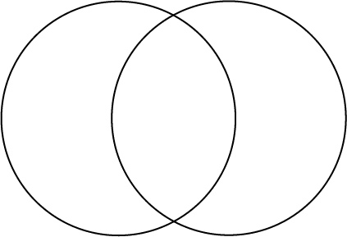
n(A $∪$ B) =

If n(A $∩$ B) = 0, then A and B are

Ex 3: In a survey of 120 customers, 80 buy Dawn, 68 buy Joy, and 42 buy both.
- How many buy at least one brand?
- Exactly one brand?
- Only Dawn?
- Neither brand?

n(A $∪$ B $∪$ C) =
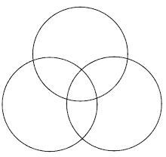

Example 4: In a survey of 100 people at a carnival:
40 like cotton candy
30 like popcorn
45 like lemonade
15 like lemonade and popcorn
10 like cotton candy and lemonade
12 like cotton candy and popcorn
5 like all three
How many people don’t like lemonade, popcorn, or cotton candy?
How many people only like popcorn?

Example 5: In a survey of 200 people regarding their investments, the following data were obtained:
141 had investments in stocks
91 in bonds
60 in money markets
47 in stocks and bonds
36 in stocks and money markets
36 in bonds and money markets
5 in some other vehicle
How many had investments in all three types?
How many had investments in stocks only?

