You try!
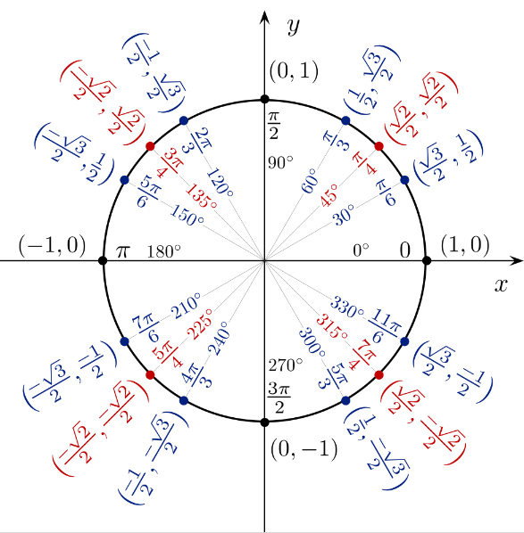
Use formulas below to find the exact value of each.
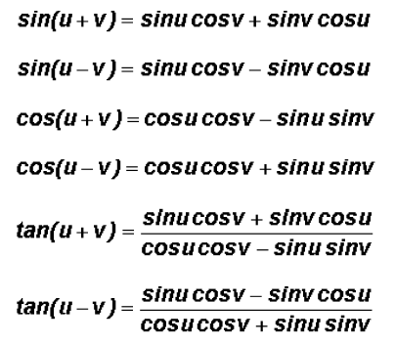

- sin 105°

- cos 75°

- tan 15°

