Name ____________________________________________________ Date ______________
6.4 Exercises – Sum & Difference Formulas
Find the exact value of each expression.
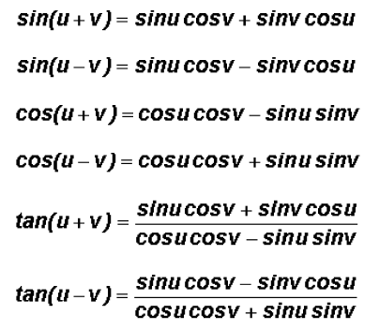
- $\sin{\frac{5π}{12}}$

- cos 165°
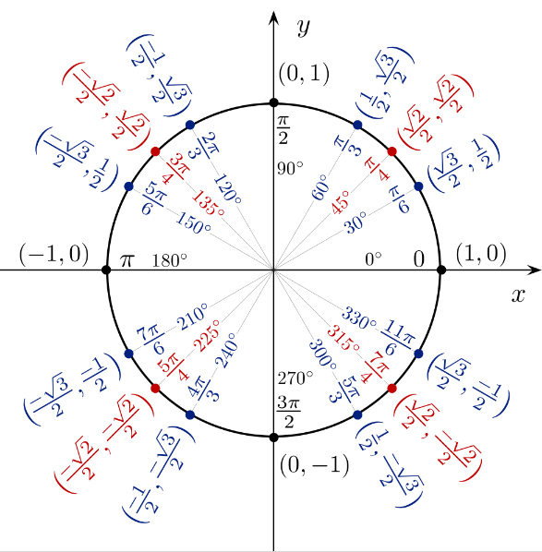

- tan 195°

- sin $\frac{7π}{12}$

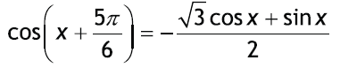
Prove each trig identity.

