ICM - 7.3 Exercises - Basic Rules of Derivatives Name _____________________________

Find the derivative of each function using the rules of derivatives.

1.

2.

3.

4.

5.

6.

7.

8.

9.

10.

11. 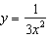

12. 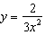

13. 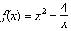

14. 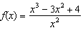

15. 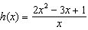

16.

17.

