ICM Guided Notes Name _______________________________ Date ________________
7.3 Rules of Probability
Probability =

Addition Rule If E and F are any 2 events of an experiment, then P(E ∪ F) = P(E) + P(F) – P(E ∩ F).

Standard Deck of Cards
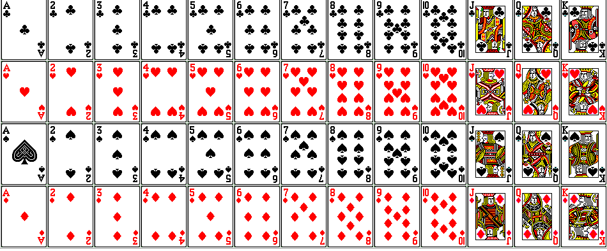
Ex. 1 A card is drawn from a well-shuffled standard deck. What is the probability that it is a king or heart?

Rule of Complements – If E is an event of an experiment and E^{c} denotes the complement of E, then P(E^{c}) = 1 – P(E).
Ex. 2 A card is drawn from a standard deck. What is the probability that it is not a king?

You Try!! : 21 ICM students are surveyed. 8 like beach music, 10 like jazz, and 5 like both jazz and beach music. Find the probability that a person selected at random from ICM likes
A) jazz or beach music or both.
B) Neither jazz nor beach music.

