Cholkar MCHS MATH II ___/___/___ Name____________________________
U3L1INV1 | How do we determine when polygons are similar?
HW # | Complete Handout [CYU, 3, 4, 35]
Do Now | 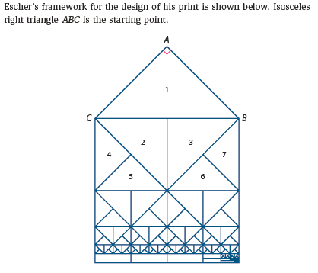  Study the Escher print and the framework used to create it.  a. How are the lizards in the Escher print alike? How are they different? How could you test your ideas?  b. Starting with the framework was created by next drawing right isosceles triangles 2 and 3. How do you think these two triangles were determined? How are triangles 2 and 3 related to each other? To triangle 1? Why?  c. How do you think triangles 4 and 5 and triangles 6 and 7 were created? How are these pairs of triangles related? How are they related to triangle 1? Explain your reasoning.  
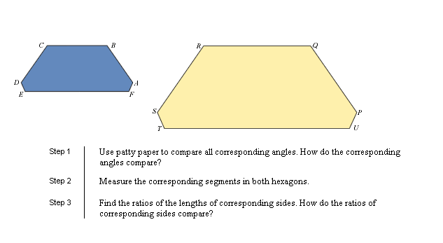
INVESTIGATION: WHEN ARE TWO POLYGONS SIMILAR (pg. 165)
My role for this investigation _________________________
Let’s explore what makes polygons similar. Hexagon PQRSTU is an enlargement of hexagon ABCDEF- they are similar!

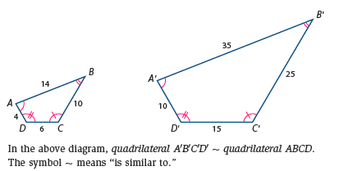
Similar Polygons: _________________________________________________________________________

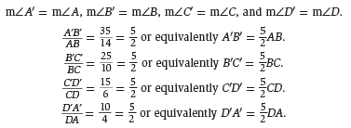

Scale factor: ______________________________________________________________________________

Pg. 166

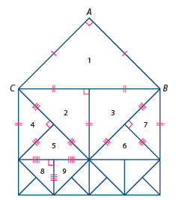
4. The diagram below is a portion of the framework for Escher’s print that you examined in the Do Now. Recall that is an isosceles right triangle. Assume BC = 2 units.

a. Compare the markings on the sides and angles of the triangles with your
analysis of the framework. Explain why the markings are correct.

_______________________________________________________

_______________________________________________________

_______________________________________________________

_______________________________________________________

b. Determine if each statement below is correct. If so, explain why and
give the scale factor from the first triangle to the second triangle. If the
statement is not correct, explain why.
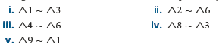

5. Based on their work in Problem 4, several students at Black River High School made conjectures about families of polygons. Each student tried to undo the previous student. For each claim, explain as precisely as you can why it is true or give a counterexample.
a. Monisha conjectured that all isosceles right triangles are similar.

__________________________________________________________________________________________

b. Ahmed conjectured that all equilateral triangles are similar.

__________________________________________________________________________________________

c. Loreen claimed that all squares are similar. ____________________________________________________

d. Jeff conjectured that all rhombuses are similar. _________________________________________________

e. Amy claimed that all regular hexagons are similar. ______________________________________________

Lesson Summary | In this investigation, you explored similarity of polygons with a focus on testing for similarity of triangles.  a. Explain why not all rectangles are similar.  b. What needs to be verified before you can conclude that two triangles, and are similar?

Math Toolkit Vocabulary: similar polygons

Cholkar MCHS MATH II ___/___/___ Name____________________________

HW #
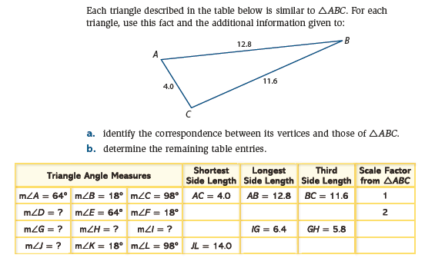
CYU pg. 168

- In the diagram, . Find the value of x.  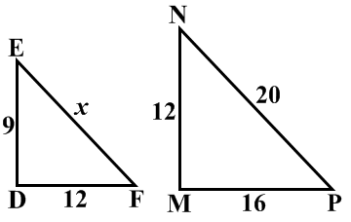 |  | - In the diagram, .  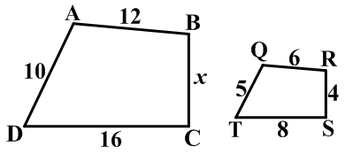  - What is the scale factor of QRST to ABCD?  - Find the value of x.
- In the diagram, .
 | 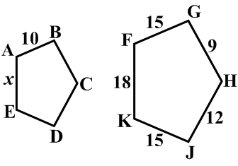 |  | - Find the scale factor of FGHJK to ABCDE.
 | - Find the value of x. |  | - Find the perimeter of ABCDE.
- In the diagram, 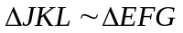. Find the length of the median 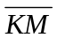.
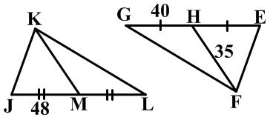

pg. 192
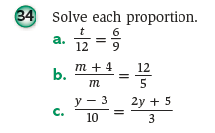

pg. 193


