Cholkar MCHS MATH II ___/___/___ Name____________________________
U1L1INV1 | How do we recognize, express, and solve problems involving direct and indirect variation?
HW # | 6.3 Ready, Set, Go 1-8 12-14 ONLY [4, 5, 8, 14]
Do Now | 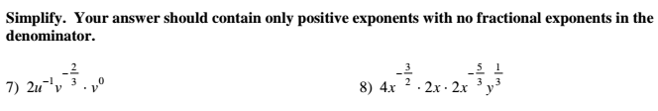  
INVESTIGATION: DIRECT AND INVERSE VARIATION (pg. 2)
{pipe, stopwatch, books}

Consider various sports that involve downhill racing. Think about the factors that decrease or increase the time it take to travel from top to bottom.

1. For downhill or slalom skiing, how will changes in the length of the course affect race time?

How will changes in vertical drop of the course affect race time?

How will changes in the distance between turns affect race time?

2. What other factors will affect downhill or slalom ski-race times? How will changes in each of those variables increase or decrease race time?

3. Pick another downhill race sport that interests you and think about the variables that affect race time in that sport event. What changes in those variables will increase the time to travel from top to bottom? What canges will decrease the time?

INVESTIGATION: ON A ROLL
My role for this investigation ______________________

1. The height of the platform and length of the ramp affect the time it takes to roll down the ramp.
a. For a fixed ramp length, how do you think the time it takes to ride down the ramp will change as platform
height increases?

b. For a fixed platform height, how do you think the time it takes to ride down the ramp will change as ramp
length increases?

c. Suppose that one skateboard ramp is twice as long as another ramp. What relationship between platform heights for those ramps do you think will allow skateboarders starting at the top of each ramp at the same time to reach the bottom at the same time?
Which of the graphs below would you expect to match the relationship between ride time and platform height in a? Which of the graphs below would you expect to match the relationship between run time and ramp length?
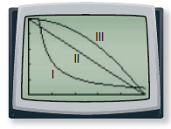
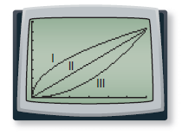

2. 2 books = .25 feet; 4 books = .5 feet
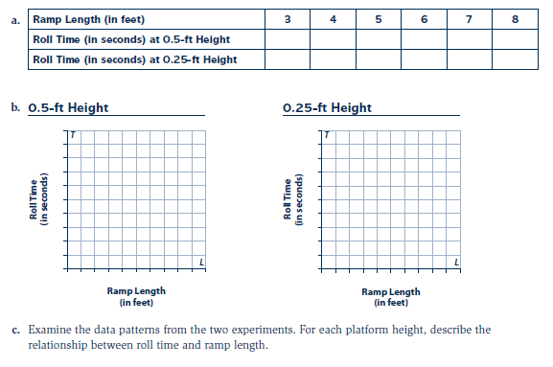

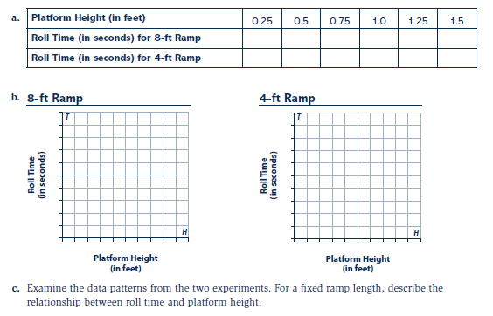
3. 2 books = .25 feet; 4 books = .5 feet; 6 books = .75 feet; 8 books = 1 foot; 10 books = 1.25 feet; 12 books = 1.5 feet

4. Compare your results from experiments in Problems 2 and 3 to your responses to the questions in problem 1. Discuss any surprises and try to reason why the results make sense.

_________________________________________________________________________________________

_________________________________________________________________________________________

5. Use separate paper for # 5.

Basic Variation Patterns

Direct variation: _________________________________________________________________________
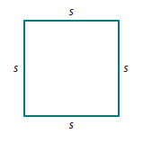
7. Explain why the perimeter P of a square is directly proportional to the length s of a side.

a. What equations shows this direct proportionality relationship? _____________

b. What is the constant of proportionality? ______

c. How does the value of P change as the values of s increases steadily? ____________________

__________________________________________________________________________________________

How is the pattern of change related to the constant of proportionality? ________________________________

__________________________________________________________________________________________
8. Which problems from Problem 5 are direct variation relationships? ________________________________

Inverse Variation:__________________________________________________________________________

9. a. _____________________________________________________________________________________

b. ________________________________________________________________________________________

c. ________________________________________________________________________________________

11. Examine the tables below, each of which describe a relation between x and y.
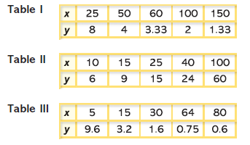

a. Which relations involve direct variation? What is the constant of proportionality in each case?

__________________________________________________________________________________________

b. Which relations involve inverse variation? What is the constant of proportionality in each case?

__________________________________________________________________________________________

Lesson Summary | Functions that model direct and inverse variation relationships have tables, graphs, and rules that are related in ways that make reasoning about them easy.  a.  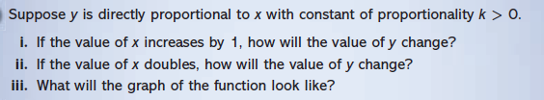  b. 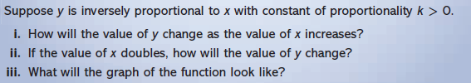

Math Toolkit Vocabulary: direct variation, inverse variation

