Cholkar MCHS MATH II ___/___/___ Name____________________________
U3L1INV3 | How can you find the length of the altitude to the hypotenuse of a right triangle?
HW # | Complete Handout [3, 4, 5]
Do Now | 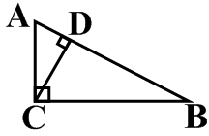  - Redraw each of the three triangles in the diagram below so that they have the same orientation as .  2. What do you notice about all 3 triangles?  
INVESTIGATION: ALTITUDE IN A RIGHT TRIANGLE
My role for this investigation _________________________

1. a. The altitude to the hypotenuse has been constructed in each right triangle below. This construction creates two smaller right triangles within each original right triangle. Calculate the measures of the acute triangles in each diagram.

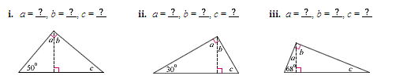

How do the smaller right triangles compare in each diagram? ________________________________________

__________________________________________________________________________________________

How do the smaller right triangles compare to the original right triangle? ______________________________

_________________________________________________________________________________________

Complete the theorem below with your new knowledge about what the altitude in a right triangle does to the original triangle.
RIGHT TRIANGLE ALTITUDE THEOREM: The altitude to the hypotenuse of a right triangle divides the triangle into two right triangles that are _________________ to each other and to the original right triangle.

b. Complete each proportion for these right triangles.
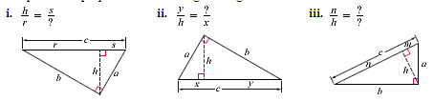

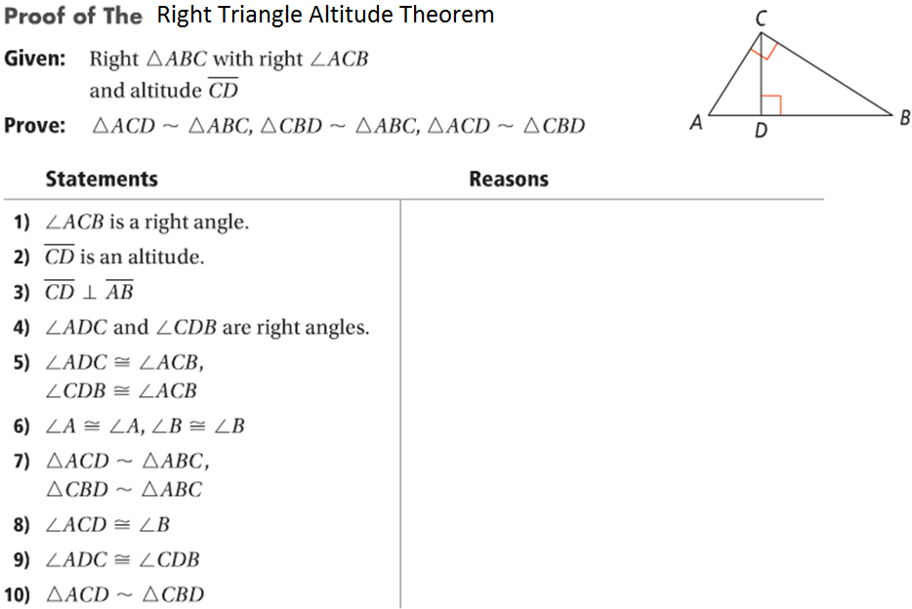

GROUP WORK
1. Identify the similar triangles and then find the value of x.
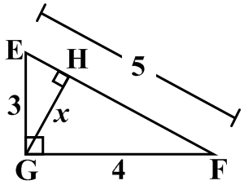

2. The accompanying diagram shows a 24-foot ladder leaning against a building. A steel brace extends from the ladder to the point where the building meets the ground. The brace forms a right angle with the ladder.
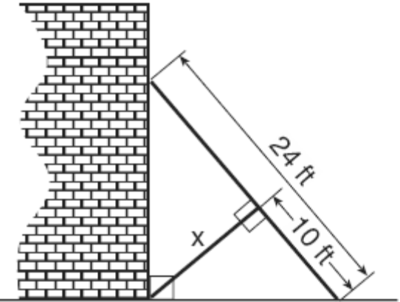
If the steel brace is connected to the ladder at a point that is 10 feet from the foot of the ladder, which equation can be used to find the length, x, of the steel brace?

Lesson Summary | In this investigation, you discovered a special property of an altitude of a right triangle.  a. Draw an example of a right triangle which has an altitude drawn within it.  b. Separate the three triangles that will be similar.
Math Toolkit Vocabulary: Right Triangle Altitude Theorem

Cholkar MCHS MATH II ___/___/___ Name____________________________

HW #

Find the value of the variable.
1.  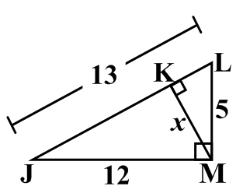 | 2.  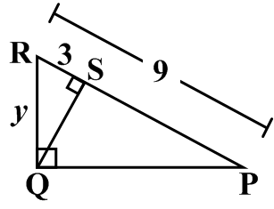
3. Four streets in a town are illustrated in the accompanying diagram. If the distance on Poplar Street from F to P is 12 miles and the distance on Maple Street from E to M is 10 miles, find the distance on Maple Street, in miles, from M to P.
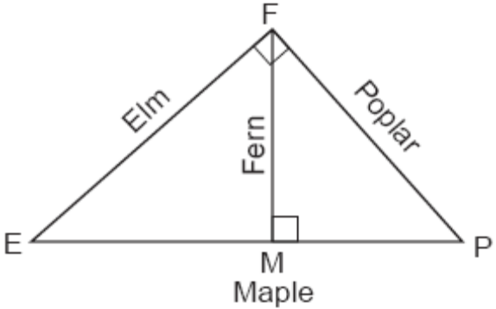

4. Find the value of a.
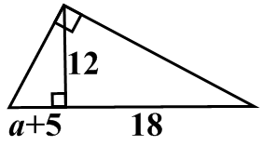

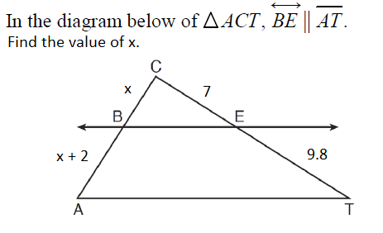
5.

