Exit Ticket | Factoring Quadratics  You can do it!  Factor Completely.  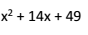  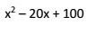  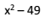  Standard NC.M1.A-SSE-3: I can write an equivalent form of a quadratic function by factoring.

Exit Ticket | Factoring Quadratics  Wow! Look at you go!  Factor Completely.  Standard NC.M1.A-SSE-3: I can write an equivalent form of a quadratic function by factoring.

Exit Ticket | Factoring Quadratics  You like a Challenge, don’t you!?  Factor Completely.  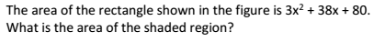  Standard NC.M1.A-SSE-3: I can write an equivalent form of a quadratic function by factoring.

