ICM HONORS – Functions Art Project
In this project, you are going to create an image using the types of functions that you have studied throughout high school and your knowledge of transforming functions. I encourage you to help each other, but you are responsible for your own individual project!
Here is an example of an image created using quadratic, linear, and absolute-value functions:
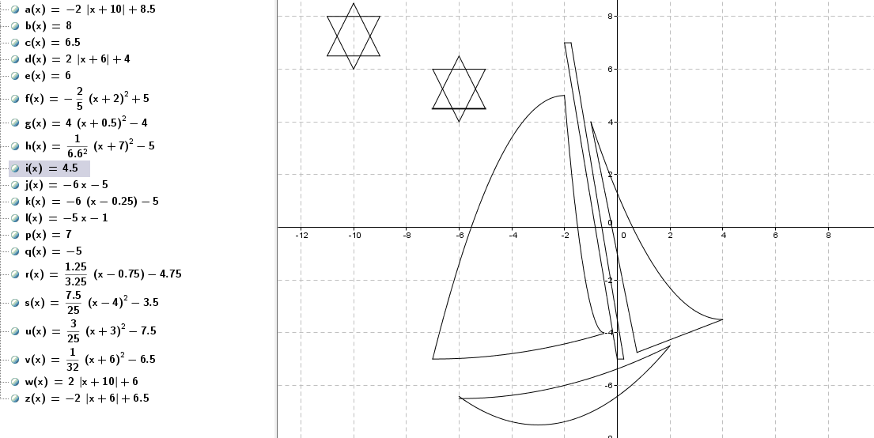
- You must use at least 6 different types of functions from the following list: Linear, Quadratic, Absolute Value, Square Root, Cube Root, Cubic, Exponential, Greatest Integer, Inverse variation, Sine, Cosine, Tangent.
- Your image must include at least 25 segments (equations total), be visually attractive, and be printed in color or have color added by you. Each person’s design needs to be sufficiently unique from others; be creative!
Step 1: Make your design on a sheet of graph paper, centered roughly at the origin (0, 0), and make sure that you have assigned coordinates to critical points on the page to help you generate the equations of the functions. You must turn in this sheet of graph paper with your project.
Step 2: Calculate the equations in your picture and include domain restrictions for them. You may use your graphing calculator and/or your knowledge about transformations and basic functions to write the equations of the functions.
Step 3: Open up a Desmos file and type in your functions, to verify that they appear as you intend. For example, in the picture above I had the linear equation j(x) = -6x – 5, but I only wanted it to go from x = -2 to x = 0. To type this into Desmos, with the domain restriction, I had to type y = -6x – 5 { into the input bar. Be sure to use the square brackets for invoking the Function command. Be sure to save your GeoGebra file as you go!
Step 4: When it is all finished, crop and print out the image of the graph (just the image, not your equations). Also make sure to save the GeoGebra file in a place that you can find again, in case you need to refer back to this later.
Step 5: Separately, print out your equations. If you have to retype them in Word, make sure the restrictions on the domain are included.
Step 6: Your equations and picture should be submitted together on a small poster (large construction paper), and be neat and attractive! The best posters will be hung up as celebration of your knowledge and creativity.
Name: ________________________________________ Teacher: __________________ Due Date: ________________
ICM HONORS – Functions Art Project Rubric (Please turn in this rubric with your project.)
CRITERIA | UNSATISFACTORY  (Below performance standards) | PROFICIENT  (Minimal Criteria) | ADVANCED  (Exceptional Perfomance)
Content  Knowledge  (60 points) | - Less than 5 different types of functions  - Has less than 20 different equations  - Has more than 5 equations that do not match the picture  - Does not include list of equations  - Does not include restrictions on the domain when necessary | - Used at least 5 different types of functions (a circle does NOT count as one of the 5 types of functions)  - Has at least 20 different equations  - Has less than 5 mistakes in the equations  - Includes a typed list of the equations  - Include restrictions on the domain and/or range when necessary  - Rough draft on graph paper matches final project (changes are allowed, but pictures should be similar) | In addition to meeting ALL PROFICIENT criteria…  - You use functions that were not on the project document (meaning you found new function to use)  - You used all thirteen (including circle) listed on the project document
Creativity  (20 points) | - Picture is not in color  - Picture is plagiarized (you will received a discipline referral)  - Equations do not make a creative art project  - Project is not presented as a poster | - The picture is in color (you may use colored pencils or markers or print your picture in color)  - Your picture is original and not plagiarized.  - Picture is creative, enjoyable, and pleasing to the eye.  - Poster is decorated with a title & theme that complements your picture | In addition to meeting ALL PROFICIENT criteria…  - Picture is very intricate (lots of details)  - Picture is of graphic design quality (has a WOW factor)
Professionalism  (10 points) | - Student did not fulfill her responsibilities  - Student did not turn rubric back in  - Project was submitted late | - Student fulfilled all of her responsibilities  - Final product is neat and of professional quality  - Rubric was turned in with project | In addition to meeting ALL PROFICIENT criteria…  - Student went above and beyond requirements for presentation of product
Reflection  (10 points) | - Student did not respond appropriately to all questions in complete sentences | - Student responded appropriately to all questions in complete sentences

Project Score: ______________ Comments:

