Middle Creek High School
Wake County Public Schools
Lacey Peckham, Principal
123 Middle Creek Park Ave
Apex, NC 27539
(919) 773-3838

Honors Math II
Instructor | Mrs. Cholkar | E-mail | rcholkar@wcpss.net
Communication | Remind Code (students): @cholkar  Talking Points Code (parents): HQSKH6 | Extra Help | Thursdays 2:30 - 3:30 or by appt  Google Meet Code: mchscholkar

Course Outline: Unit 1: Transformations
Unit 2: Congruence
Unit 3/4: Quadratic Functions
Unit 5: Solving Quadratic Functions
Unit 6: Rational, Inverse, & Radical Functions
Unit 7: Similarity & Trigonometric Functions
Unit 8: Probability

Expectations:
- Be respectful of your classmates, your teachers, and yourself.
- Come to class prepared and willing to learn.

Daily Materials:
MVP Math 2 books (digital copy provided - paper copy available for pick up at MCHS)
Notebook/Binder/Folder with notebook paper and graph paper
Pencils/Pens
Graphing Calculator Options
- Purchase TI-83/TI-84 Graphing Calculator ($100-$130)
- Download Android App: wabbit emu (free)
- Download IOS App: GraphNcalc83 (free)
- Use Desmos online or app (free)

Joining Google Classroom:
- Option 1: Go to the Wake ID Portal Wake ID Portal
- Option 2: MCHS Website http://www.wcpss.net/middlecreekhs
  - Student Username (The first part of your email address)
  - Enter Your Password
  - Select Google Classroom
  - Use the + Key to Join with Code
(Block 2) hjjxlj7 (Block 4) r25x6vs

Classroom Procedures (if in person):
- Bring all necessary materials to class.
  - Come to class with a sharpened pencil and paper.
  - Come to class with your binder and last night’s homework.
- Open your laptop and access google classroom. The daily “Do Now” or “Warmup” will be posted for you to begin working on independently.
- If you are in school and late to class, follow the following procedure:
  - Walk into the class quietly
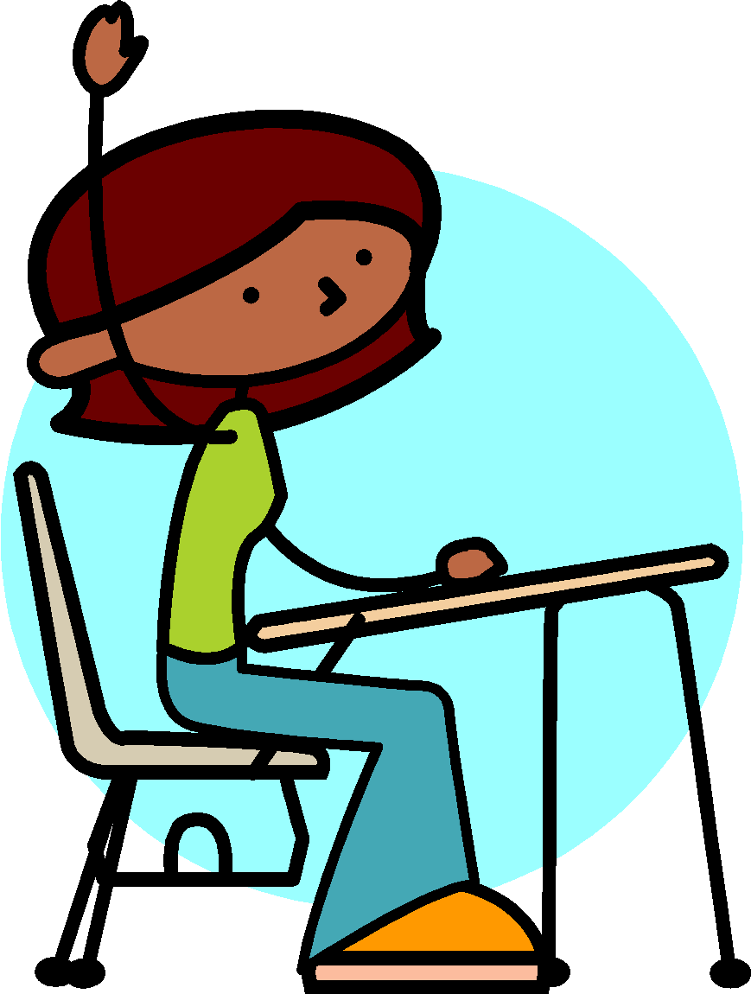
  - Sit in your assigned seat
  - Open up your laptop and access google classroom
- Raise your hand and wait to be called on before speaking
or leaving your seat.
  - If you need to go to the bathroom, follow the following procedure:
    - Quietly raise three fingers and I will know this means bathroom and non-verbally acknowledge you to take the pass and go.
    - Reminder: Students will have designated times to utilize the bathroom this semester.
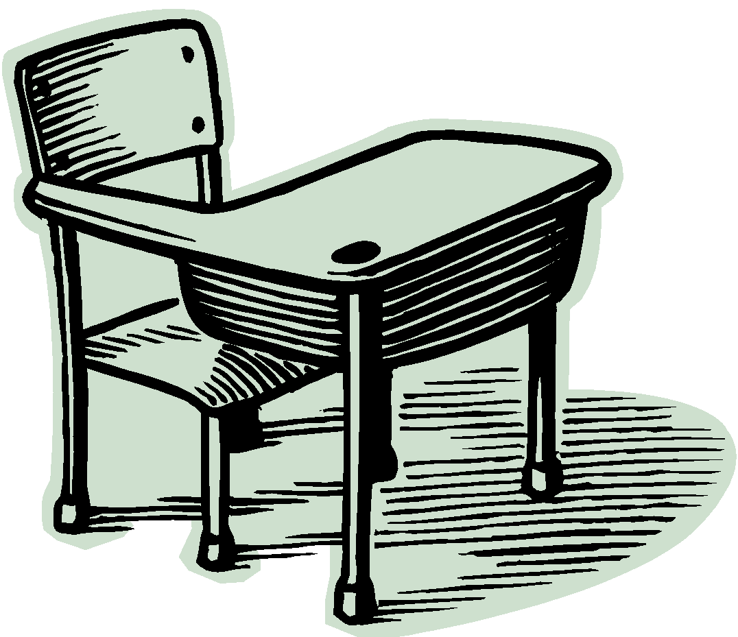
- When you are absent, please:
  - Access google classroom and determine what you missed.
- Before leaving class, please use an antibacterial wipe to clean the top surface of your desk.

Grading Policy
Tests 60%
Quizzes 25%
Classwork/Homework 15%
Total 100%

Tests/Quizzes:
- Tests will be given approximately every 2 or 3 weeks. Tests will be announced at least 3 days prior to the exam date.
- Quizzes will be given when I feel they are appropriate. Quizzes will be announced at least 2 days in advance.
- There are unit exam retakes (if needed). It will be the average of the two test grades with the highest grade allowed being an 80%.
- If you pay attention, complete all of your homework, and ask questions when you have them, you will be successful on class assessments.

Classwork/Participation:
- Your classwork/participation grade is based on your active participation and effort in all activities.

Homework:
- Homework is assigned and checked every day
- If you missed a homework assignment, you may turn it in late for a 60% by the end of the unit.

