**ICM Unit 1 Review – Sets & Counting** Name______________________________

**For items 1 – 2, let **, , and .**

**1.** Find . **2.** Find .

**3.** Let ** and . Find .

**4.** Let **, , and . Find .

**For items 5 – 6, let **, , and .**

**5.** Find . **6.** Find .

**7.** If , , and , then find *.*

**8.** If , , and , then find *.*

**9.** 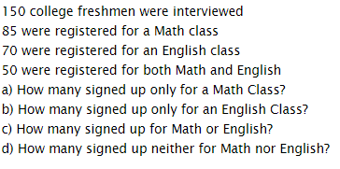

**10.** To determine which restaurants are liked in Plattsburgh, a survey of 100 inhabitants is taken with the following results. Sixty-two liked Betty’s Burger Basket, 47 liked Stella’s Sturgeon Stampede, 32 liked Larry’s Liver Lounge, 17 liked Larry’s Liver Lounge and Betty’s Burger Basket, 20 liked Betty’s Burger Basket and Stella’s Sturgeon Stampede, 12 liked Stella’s Sturgeon Stampede and Larry’s Liver Lounge, and 5 liked all three restaurants.

**A.** How many liked Betty’s Burger Basket and Stella’s Sturgeon Stampede, but not Larry’s Liver Lounge?

**B.** How many liked none of the three restaurants?

**11.** A cafeteria offers a Combo, which consists of a choice of sandwich and a drink. If there are 5 different sandwiches and 4 different drinks available, how many different Combos are possible?

**12.** If 5 people enter a room that has 9 chairs. In how many ways can they be seated?

**13.** A robber has stolen a locked briefcase. The lock on the briefcase can be opened with a three-digit code, where each digit is a letter A, B, C, D, E, or F.

**A.** How many codes are possible if each digit may be used more than once?

**B.** How many codes are possible if each digit may be used only once?

**14.** There are 20 people in a club. In how many ways can the club elect a president, a secretary and a treasurer, if no person can hold more than one office?

**15.** Find the number of distinguishable permutations that can be formed from the letters of each word

**A.** JOKE.

**B.** LAGOONS.

**16.** In order to pass an English class, a student must read ten books from a reading list which contains thirty books. In how many ways can the student fulfill the requirement?

**17.** A Senate committee consists of 8 Republicans and 10 Democrats. A subcommittee of 5 members is to be formed from the members of the committee.

**A.** In how many ways can the subcommittee be formed?

**B.** In how many ways can the subcommittee be formed if only Democrats are chosen?

**C.** In how many ways can the subcommittee be formed if the subcommittee must contain 2 Republicans and 3 Democrats?

**18.** An exam consists of ten multiple choice questions.

**a.** How many ways can a student score an 80? (answer exactly 8 of the ten questions correctly)

**b.** How many ways can a student score at least an 80? (answer 8, 9 or 10 questions correctly)

**19.** Michelle, a realtor, gathered the following information from the files of her most recent 150 clients:

70 clients were first-time home buyers.

90 bought homes that cost more than $200,000.

100 bought homes in Raleigh.

75 bought homes in Raleigh that cost more than $200,000.

35 were first-time home buyers who bought homes in Raleigh.

30 were first-time home buyers who bought homes that cost more than $200,000.

8 were in none of these three categories.

1. How many of her clients were first-time home buyers who spent more than $200,000 on a home in Raleigh?
2. How many clients spent more than $200,000 on a home that was not in Raleigh?



**20.**

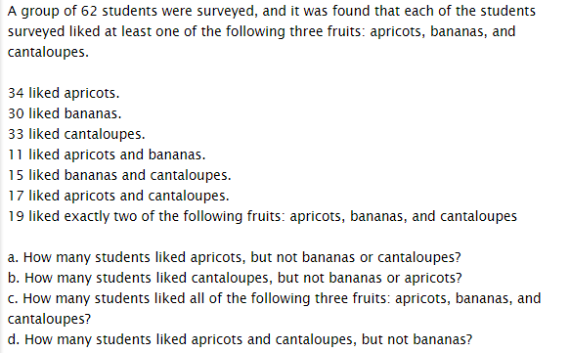**21.**