Cholkar MCHS MATH II ___/___/___ Name____________________________
U5L INV1 | What can we discover about the relationship in special right triangles?
HW # | Complete Handout [3, 5, 7]
Do Now | Find the unknown side length of the right triangle. If necessary, leave your answer in simplified radical form.  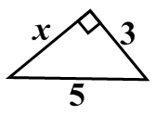  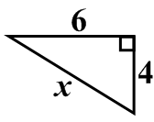  a. b.
INVESTIGATION: DISCOVERING SPECIAL RIGHT TRIANGLE RELATIONSHIPS
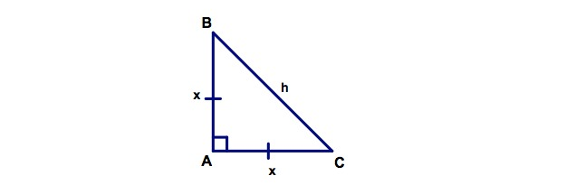
My Team role for this investigation:__________________

- What are the measures of <B and <C? Explain how you arrived at your answer.

- Classify the triangle by its angles and sides.

- Write the Pythagorean Theorem. Write an equation in terms of x and h by substituting the side lengths in the formula.

- Solve for h. Your answer must be in simplified radical form.

- Redraw the triangle above, substituting your answer from step 4 for h on the diagram.

- Summarize your findings in a complete sentence.

- Draw a DEF similar to ABC where <D is the right angle, DE=5 and DF=5.

- What is the measure of <E? <F? Explain your answer.

- What is the length of EF? Explain how you found your answer. Does this answer coincide with your findings in #6?

***In every 45-45-90 triangle, the relationship of the sides is _________________.

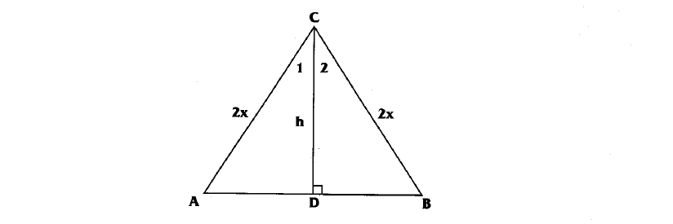

- ABC is an equilateral triangle. What is the measure of:
<A= <B= <ACB=
- is an altitude of ABC. What does do to segment AB?

- Based on your answer to problem #2, find the following lengths in terms of x and write them on the diagram.
AB= AD= BD=
- is an altitude of the equilateral ABC. What does do to <ACB?

- Find the following angle measures: m<1= m<2=

- Highlight DBC. It is a 30-60-90 triangle. Write the Pythagorean Theorem. Write an equation, substituting the side lengths of , , and .

- Solve the equation written in step 4 for h. Leave your answer in simplest radical form.

- Redraw the triangle above, substituting your answer from step 5 for h on the diagram.

- Summarize your findings in a sentence.

- Fill in the following sentences:
***In every 30- 60 -90 triangle, the hypotenuse is ___________ compared to the side opposite the 30º angle.
***In every 30-60-90 triangle, the side opposite the 60º angle is ___________ compared to the side opposite the 30º angle.
GROUP WORK
For each problem, find the lengths of the other two sides of the triangle. Please put the answers in simplified
radical form.
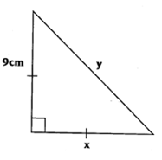a. | 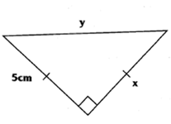b. | 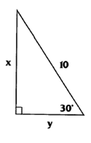c.
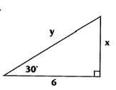d. | 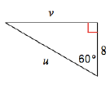e. | 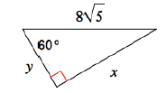f.
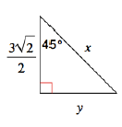g. | 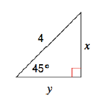h. | 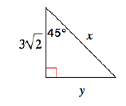i.

Lesson Summary | What is the relationship among the sides in a 30-60-90 triangle? A 45-45-90 triangle?
Math Toolkit Vocabulary Entry: 30-60-90, 45-45-90 Right Triangles

Cholkar MCHS MATH II ___/___/___ Name____________________________

HW #
Solve for the missing sides in each of the given triangles using the relationships for special right triangles. Leave all answers as simplified radicals.

x
y
15
45°

45°
y
x

x
y

x = ____________
y = ____________
x = ____________
y = ____________
x = ____________
y = ____________

26
y
60°
x

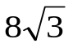
30°
x
y

60°
x
y
28

x = ____________ x = ____________ x = ____________
y = ____________ y = ____________ y = ____________
REVIEW:
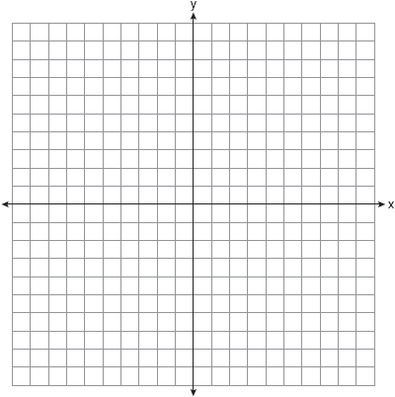
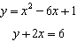
7. On the set of axes below, solve the following system of equations graphically for all values of x and y

