
Cholkar MCHS MATH II ___/___/___ Name____________________________
U5L1INV5 | How do we simplify and rewrite expressions with radicals?
HW # | Complete Handout [1b, 1e, 2h, 2j, 2l, 3]
Do Now | Find the value of x.  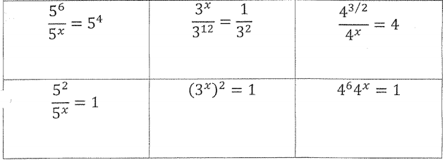

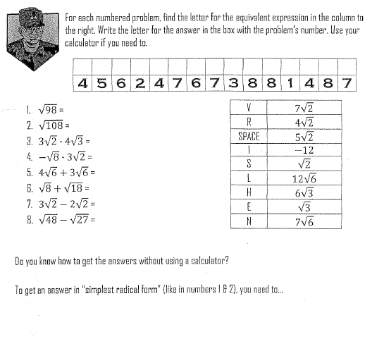
INVESTIGATION: WHERE DOES A GENERAL KEEP HIS ARMIES?

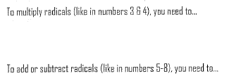

SIMPLIFYING RADICALS
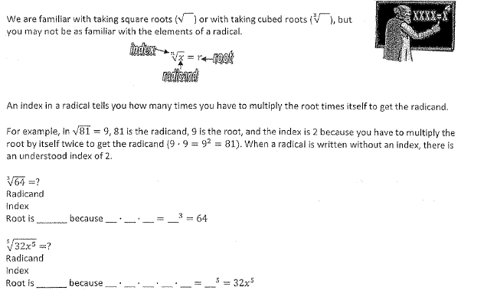
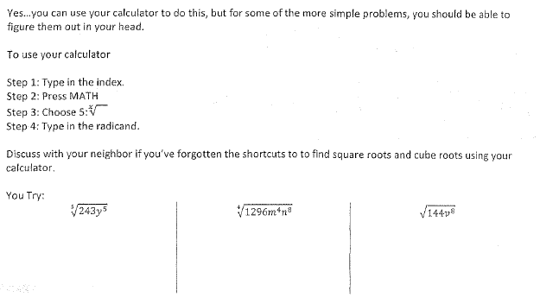

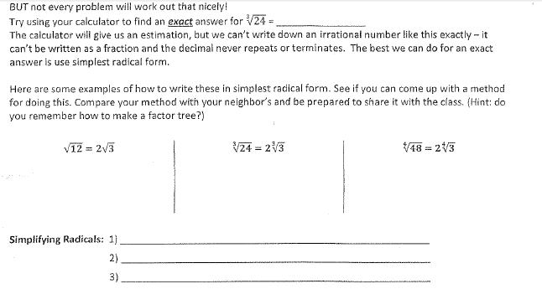

GROUP WORK
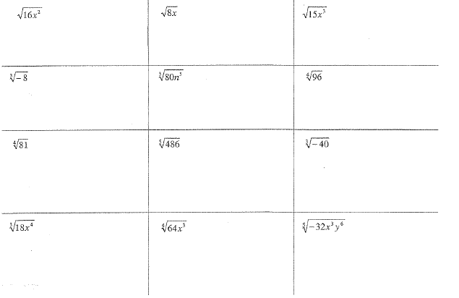

Lesson Summary | In this investigation, we discovered and discussed ways to simplify a radical. List the three ways we discussed we can simplify a radical.
Cholkar MCHS MATH II ___/___/___ Name____________________________

HW #

1. Simplify the following.
- 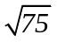 | - 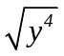 | - 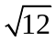
- 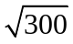 | - 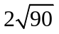 | - 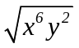

2. Write each expression in simplest form.
- 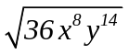 | - 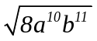
- 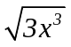 | - 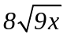
- 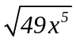 | - 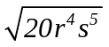
REVIEW:
m. 3. The graph of is shifted up 3 units and right 5 units. Which equation represents the resulting graph?

a. |  | c.
b. |  | d.

