Name____________________
Angles of Elevation and Depression
- Angles of Elevation and Depression
- The angle of elevation is the angle formed by a _________________ and the line of sight looking up.
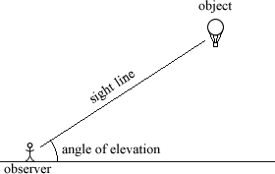

  - The angle of depression is the angle formed by a _______________ and the line of sight looking down.
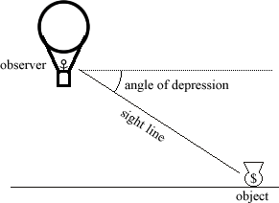

  - Notice … the angle of elevation and the angle of depression are _____________________________ when in the same picture!
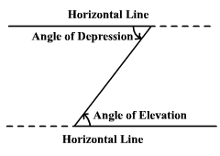

Set up and solve the following. Start with a picture!
Example 1: At a certain time of day the angle of elevation of the sun is $44°$. Find the length of the shadow cast by a building that is 30 meters high.

Example 2: The top of a lighthouse is 120 meters above sea level. The angle of depression from the top of the lighthouse to the ship is $23°$. How far is the ship from the foot of the lighthouse?

Example 3: A lighthouse is 100 feet tall. The angle of depression from the top of the lighthouse to one boat is$24°$. The angle of depression to another boat is $31°$. How far apart at the boats?

Example 4: Rachel spotted her car from a weather balloon. She knows her altitude is 82 meters and her angle of depression is 32º. She wants to know how far she is from her car.

Example 5: You stand 40 ft from a tree. The angle of elevation from you the top of the tree is 47º. How tall is the tree?

Example 6: The angle of elevation to the top of a building is 22º. You know the building is 450 meters tall. How far are you from the building?

