**Cholkar MCHS MATH II ___/___/___ Name____________________________**

HW # 7

|  |  |
| --- | --- |
| 1. In the diagram,  is the perpendicular bisector of . Find . | 1. If  is the perpendicular bisector of , what is the value of *AB*? (Find *x* first.) |
| 1. If  and , what is the length of *LM*? | 1. Draw point *Q* anywhere on . If , what is the length of *MQ*? |

|  |  |
| --- | --- |
| 5. | 6. |
| 7. Find the value of x. | 8. Find the value of x. |

**REVIEW:**

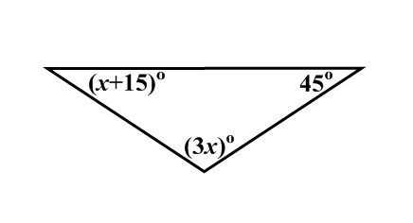9. Find the value of *x* and classify the triangle by its angles.

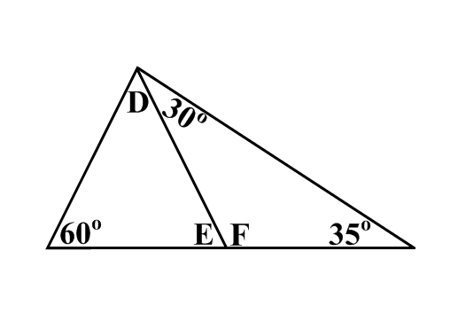

10. Find the measure of angles *D*, *E*, and *F*.

11. In , , , and . What type of triangle is ? Explain your reasoning.