**Cholkar MCHS MATH II ___/___/___ Name____________________________**

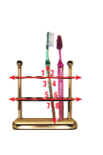

HW # 8

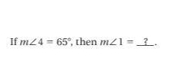

1. Find the angle measure. Tell which postulate or theorem you use.

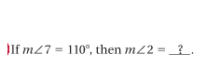a.

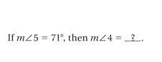b.

c.

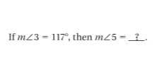

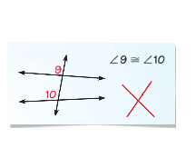d.

2. A student concludes that 910 by the Corresponding Angles

Postulate. Describe and correct the error in his reasoning.

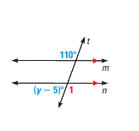

3. What is the value of *y* in the diagram?

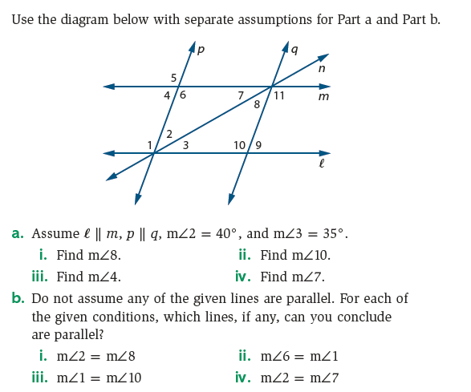

4.

**REVIEW:**

5. Use the following picture to fill in the blanks below:

|  |  |
| --- | --- |
|  | * 1. _______ and _______ are a linear pair.   2. _______ and _______ are also a linear pair.   3. _______ and _______ are vertical angles. |

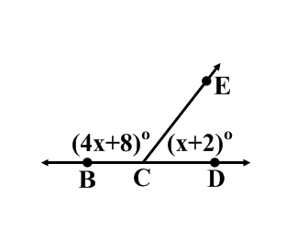

6. Find  given the picture to the right: