Cholkar MCHS MATH II ___/___/___ Name____________________________
U3L2INV1 | How do was translate, rotate, and reflect figures in the coordinate plane?
HW # | Complete Handout [4, 7, 17, 19, 38]
Do Now | Begin reading on pg. 195.  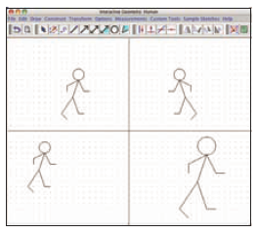  The computer graphics display above shows some of the ways in which a figure in a coordinate plane can be transformed in terms of position and/or size.  a. How could you create the humanoid in the second quadrant using interactive geometry software? How could you describe the figure using coordinates?  b. What transformation of the figure in Quadrant II would produce the image in Quadrant I? The image in Quadrant III? The image in Quadrant IV?  c. How do you think coordinates might be used to describe these transformations?  

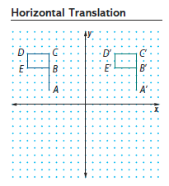
INVESTIGATION: COORDINATE MODELS OF TRANSFORMATIONS (pg. 195)
My role for this investigation _________________________

2. translation: _________________________________________

a. Describe the translation as precisely as you can.

________________________________________________________

b. Explain how the translated image of the flag could be produced using only the translated images of points A, B, C, D, and E.
__________________________________________________________________________________________

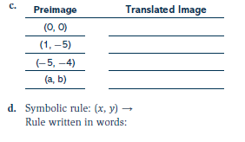
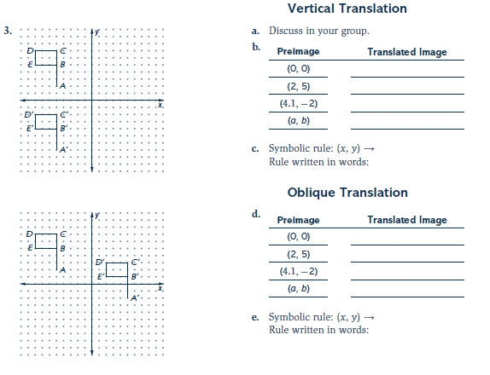
4. General rule: ________________________

6. rotation: _____________________________________________________________________________

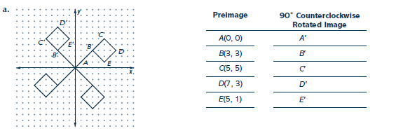

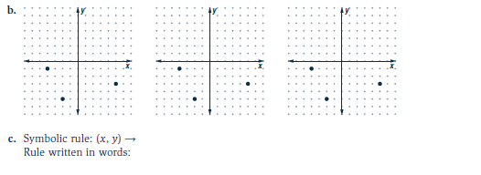

d. _______________________________________________________________________________________

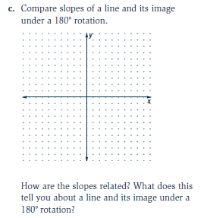
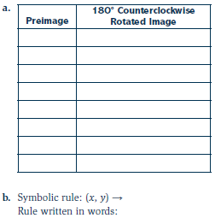
7.

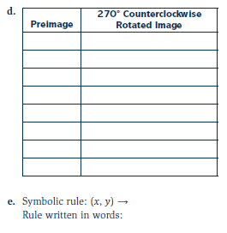

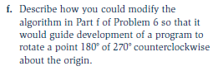

8. line reflection: _______________________________________________________________________

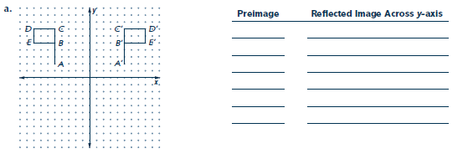

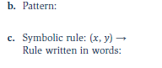

d. ______________________________________________________________________________________

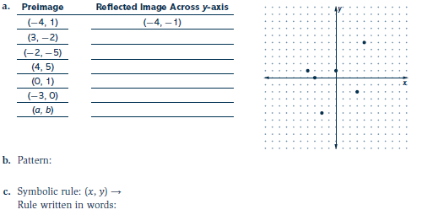

d. _______________________________________________________________________________________

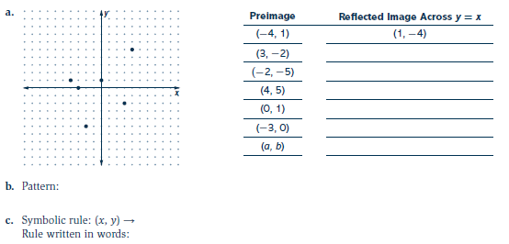
10.

d. _______________________________________________________________________________________

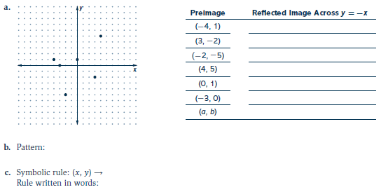
11.

d. _______________________________________________________________________________________

Lesson Summary | 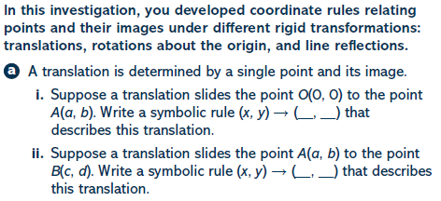  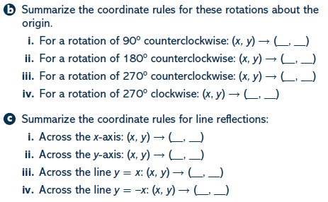
Math Toolkit Vocabulary: rigid transformations, similarity transformations, translate, rotate, line reflections
Cholkar MCHS MATH II ___/___/___ Name____________________________

HW #

- The image of point (3,-5) under the translation that shifts (x,y) to (x–1,y–3) is… |  | - What is the image of point (-3, 4) under the translation that shifts (x,y) to 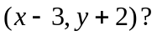
- A translation moves P(3,5) to 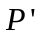(6,1). What are the coordinates of the image of point (–3,–5) under the same translation? |  | - The image of point (-2,3) under translation T is (3,-l). What is the image of point (4,2) under the same translation?
- The image of the origin under a certain translation is the point (2,-6). The image of point (-3,-2) under the same translation is the point… |  | - Triangle ABC has vertices A(1,3), B(0,1), and C(4,0). Under a translation, A′, the image point of A, is located at (4,4). Under this same translation, point C′ is located at point…
- Find the image of  after the transformation (x, y) (x + 1, y – 2).  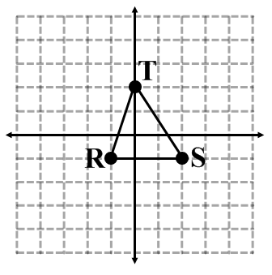 |  | 9. Translate Q (0, -8) using 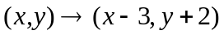.
10. What is the image of point (–3,–1) under a reflection in the origin 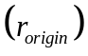?  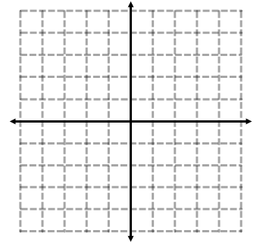 | 11. In the accompanying graph, if point P has coordinates 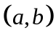, which point has coordinates 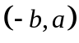? |  | 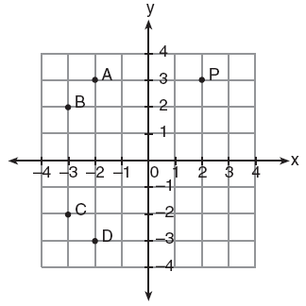
12. If point A is located at (4,-7), what is the image of this point after the transformation 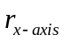? | 13. Point (-2, 3) is reflected in the x-axis. In which quadrant does its image lie?  (1) I (2) II (3) III (4) IV
14. What is the image of point (-3,7) after a reflection in the y-axis? | 15. What are the coordinates of point 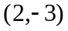 after it is reflected over the y-axis?
16. If point (5,2) is rotated counterclockwise 90° about the origin, its image will be point… | 17. What are the coordinates of point P, the image of point (3,–4) after a reflection in the line y = x?
18. Triangle DEG has the coordinates 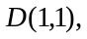 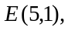 and 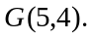 Triangle DEG is rotated 90° counterclockwise about the origin to form 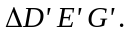 On the grid below, graph and label  and State the coordinates of the vertices D', E', and G'.   | 19. On the accompanying set of coordinate axes, reflect ABCD over the y-axis if A(2,6), B(7,8), C(9,3), and D(4,l). Sketch and label ABCD and its image. Then find the number of square units in the area of ABCD.  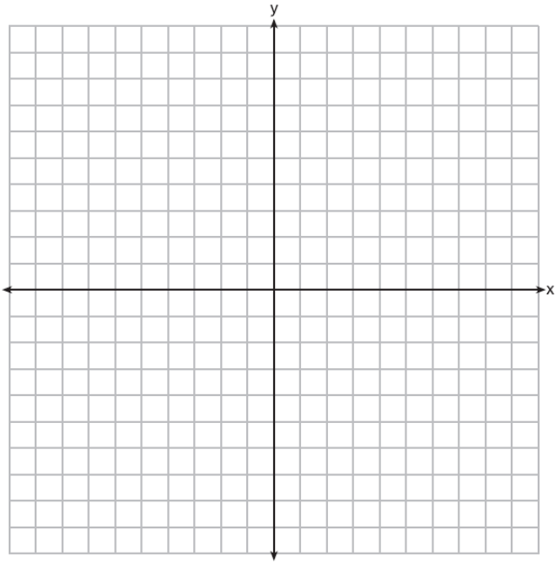

Pg. 229
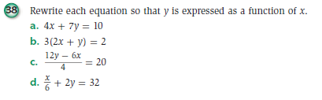

Pg. 230


