Dilations Practice Name: _____________________

Graph and label each figure and its image under the given reflection. Write the rule using formal notation.

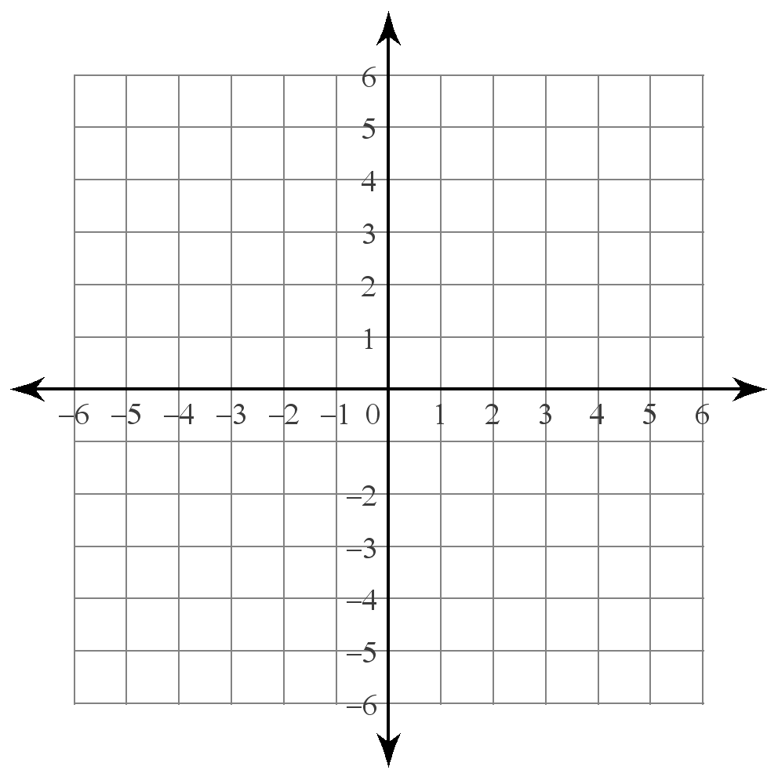
1) Dilate $∆$QRS if Q(-1, 0), R(-1, 2), S(-2, 1) 2) Dilate $∆$TRK if T(-1, -2), R(1, 0), K(0, 1)
by a magnitude of 2 from the origin. by a magnitude of 3 from the origin.

Q’ ______ T’ ______
R’ ______ R’ ______
S’ ______ K’ ______

Rule: _________ Rule: _________

3) Dilate $∆$XYZ if X(-4, 0), Y(-4, 3), Z(-2, -2) 4) Dilate $∆$IBM if I(2, -4), B(1, 2), M(4, 1)
by a magnitude of $\frac{1}{2}$ from the origin. by a magnitude of $\frac{3}{2}$ from the origin.

X’ ______ I’ ______
Y’ ______ B’ ______
Z’ ______ M’ ______

Rule: _________ Rule: _________

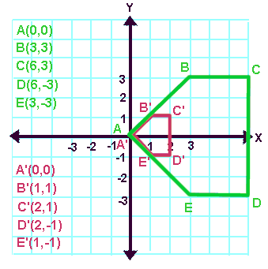
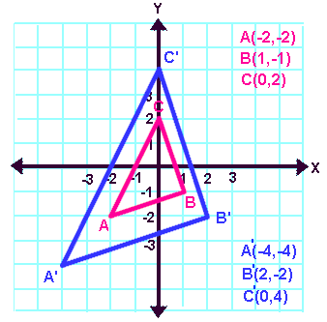
Determine the scale factor that was used to dilate the following figures.
5) 6) 6)

Scale Factor: ______________ Scale Factor: ______________

