Unit 2 Lesson 5 Notes
Learning Outcomes | How can I prove the sum of the angles of any triangle?  How can I determine if a triangle is an isosceles triangle?
Do Now | 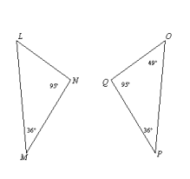  Find m$<$L.
NOTES: POSTULATES AND THEOREMS ON TRIANGLES

TRIANGLE SUM THEOREM:

LINEAR PAIR POSTULATE:

TRIANGLE EXTERIOR ANGLE THEOREM:

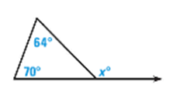
Examples:
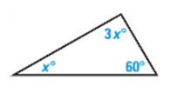
Find the value of x.
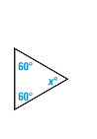
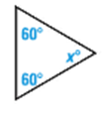
1. 2. 3.

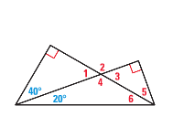
4. Find the measure of the numbered angles.

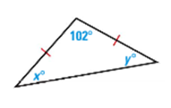
5. Find the value of x and y.
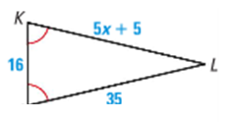
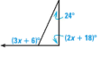
a. b. c.

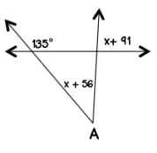
d. e.
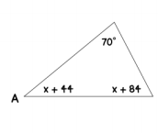

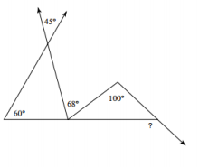
6. Find the missing angle measures in the triangle.
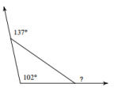
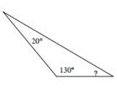
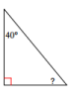
a. b. c.

d.

