**Cholkar MCHS MATH II ___/___/___ Name____________________________**

HW # 6

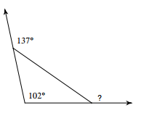1. Find the missing angle measures in the triangle.

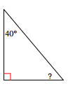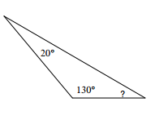

a. b. c.

d. 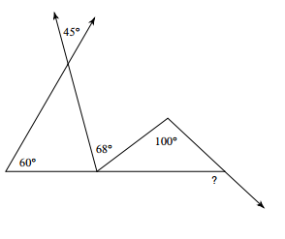

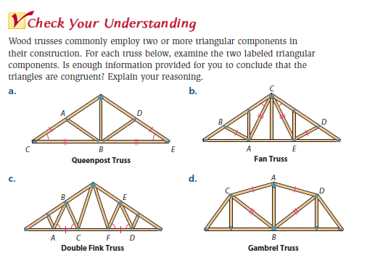

2.

3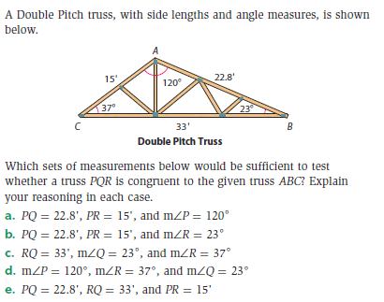.

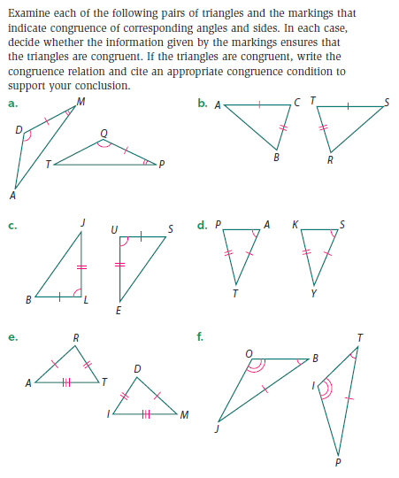4.