Concepts and Vocabulary
Four Types of Transformations: Translations, Rotations, Reflections, and Dilations.
Congruent Figures have the same size and shape. Translations, rotations, and reflections create figures that are congruent.
Similar Figures have the same shape. Dilations create figures that are similar but not congruent.
Practice Questions
____ 1) The vertices of a rectangle are R (2, 4), S (5, -1), T (-7, 7), and U (-4, 6). After a translation, R’ is the point (3, -1). Write the translation rule and the coordinates of U’.
A) (x,y) -> (x + 1, y -5 ); (-3, 1) B) (x,y) -> (x - 1, y - 5 ); (-3, 1)
C) (x,y) -> (x + 1, y + 5 ); (-3,11) D) (x,y) -> (x - 1, y + 5 ); (-5, 11)
____ 2) Write a rule to describe the transformation that is a reflection in the y-axis.
A) (x, y)→(-x, -y) B) (x, y)→(y, x) C) (x, y)→(-x, y) D) (x, y)→(x, -y)
____ 3) Which rules describe the translation that is 5 units to the right and 3 units up?
A) (x,y) -> (x +5, y -3) B) (x,y) -> (x -5, y -3)
C) (x,y) -> (x -5, y + 3) D) (x,y) -> (x + 5, y + 3)
4) What type of transformation is shown in the image below?
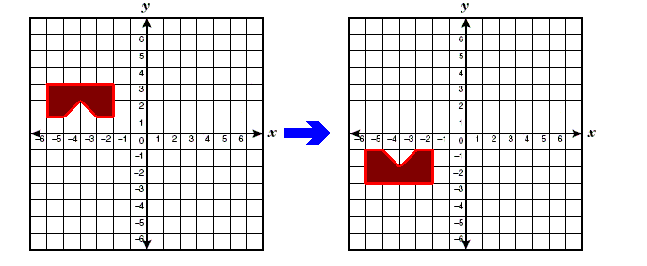
A. Reflection in the x-axis B. Reflection in the y-axis
C. Rotation of 90 degree counterclockwise D. Dilation with a scale factor of -1
5) If ∆QRS is dilated with a scale factor of 4 what are the coordinates of the image points Q’, S’ and R’?
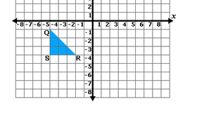
Q’ __________
S’ ___________
R’____________
____ 6) Sammy plots the point (10, 3) on a coordinate grid. He reflects this point over the x-axis, then over the y-axis. What are the coordinates of the image point after both reflections?
A) (-10, 3) B) (-3, 10) C) (-10, -3) D) (10, -3)

7) What would be the coordinates of the images of points A,B,C, and D from the trapezoid below after a reflection over the line y=x? Graph the image of ABCD under this reflection.
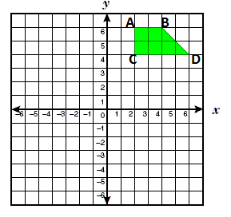
A’ __________
B’ ___________
D’____________
C’ ___________
8) What would be the coordinates of point D’, the image of point D from the trapezoid above, after a rotation of 90 degrees counterclockwise about the origin?
D’: ________________________________
Unit 2 Test Review: Spiral Questions from Unit 1 Solutions
1- A 2- C 3- D 4-A 5. Q’(-20,-4) / S’(-20,-16) / R’ (-8,-16)
6. C 7. A’(6,2) B’(6,4) D’(4,6) C’(4,2)
8. D’(-4,6)

