Cholkar MCHS MATH II ___/___/___ Name____________________________

Lesson 3 Congruent Triangles Notes

ANGLE-SIDE-ANGLE (ASA) CONGRUENCE POSTULATE: If two angles and the included side of one triangle are congruent to two angles and the included side of another triangle, then _______________________________________.

Diagram:

SIDE-ANGLE-SIDE (SAS) CONGRUENCE POSTULATE: If two sides and the included angle of one triangle are congruent to two sides and the congruent angle of another triangle, then ______________________________.

Diagram:

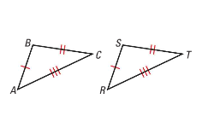
SIDE-SIDE-SIDE (SSS) CONGRUENCE POSTULATE: If three sides of one triangle are congruent to three sides of another triangle, then ______________________________.

Diagram:

ANGLE-ANGLE-SIDE (AAS) CONGRUENCE POSTULATE: If two angles and a non-included side of one triangle are congruent to the corresponding angles and side of another triangle, then ___________________________________________________.

Diagram:

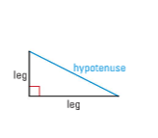

HYPOTENUSE-LEG (HL) CONGRUENCE THEOREM: If the hypotenuse and a leg of a right triangle are congruent to the hypotenuse and a leg of a second right triangle, then ________________________________.

