- 2.1: Experiments, Sample Spaces, & Events
- 2.2: Definition of Probability
- 2.3: Rules of Probability
- 2.4: Using Counting Techniques in Probability
- 2.5: Conditional Probability
- 2.6: Bayes Theorem

2.1:
Vocabulary:
-Experiment: an activity with observable results (outcomes)
-Sample point: an outcome of an experiment
-Sample space: a set of all possible sample points
-Event: a subset of a sample space
-Mutually exclusive: events A and B equal zero (A⋂B=0)
-Complementary events: event B equals the complement of event A (A∁=B)
-Non-discrete: a sample space that is too long to list

Examples:
- S={a,b,c,d,e,f,g,h,i} A={a,b,c} B={a,f,g,h,i} C={d,g,i}
A⋂B=
A⋃B=
B⋃C=
A^{c}⋂B=
C^{c}∪A=
- Rolling a dice
List event A rolling an even number=
List event B rolling a multiple of 3=
A∪B=
A⋂B=
A^{c}=

2.2:
Vocabulary:
-Simple event: events that contain one point of an experiment (simple events are always mutually exclusive)
-Probability: a measure of the proportion of the time that the event will occur at a time
- suppose that in N trials an event E occurs M times. The relative frequency is M/N
-Theoretical probability: what you expect to happen, but it isn't always what will actually happen
-Empirical probability: probability determined from the results of the experiment
-Probability distribution table: a table that lists the probability of each event of an experiment
Properties:
- Probability of each simple event is between 0 and 1 inclusive
- The sum of all probability events in a sample space is 1
- The probability of the union of 2 mutually exclusive events is given by the sum of their probabilities

Examples:
- Given the sample space {S1,S2,S3}, list the simple events
- An opinion poll is conducted with a group of voters (D,R,I) and if they are in university (U) or working (W). Give the sample space and simple events
- Evan tosses a coin 3 times, and called heads. Find the probability distribution table for P(number of heads)

2.3:
Vocabulary:
-Additional Rule: If E and F are any two events of an experiment, then p(E ∪ F) = P(E) + P(F) - P(E ∩ U)
- Ex: a card is drawn from a standard deck of cards. What is the probability of a queen or diamond? P(Q ∪ D) = P(Q) + P(D) - P(Q ∩ D)
-Rule of Complements: If E is an event of an experiment and E^c denotes the complement of E, then P(E^c) = 1 - P(E)
- Ex: A card is drawn from a standard deck. What is the probability that it is not a diamond? 1 - P(D^c)
Examples:
- If a card is drawn from a deck of cards, that is the probability of drawing a Jack, Spade or Ace?

- A card is drawn from a random deck of cards. What is the probability of not drawing a Jack? Not the Probability of drawing a Spade. Not the probability of drawing an ace?

2.4 Vocabulary: Terms
-Probability = number of favorable outcomes
-------------------------------------------
number of possible outcomes
-P(E) = n(E)
-----
n(S)
-at most: or, add (+)
-Calculator Rules: MATH, PRB, 3 (nCR)

Ex 1) Three marbles are selected at random without replacement from a jar with 3 black, 2 white, and 3 red marbles. Find the probability that…
a) All 3 marbles are black.

b) One is white and two are red.

Ex 2) Kennadi is studying for a spelling bee and knows the meanings of 20 words from a list of 30. If the test has 10 words from the list, find the probability that the student will score at least an 80%.

Ex 3) Assuming that the probability of a boy being born is the same as the probability of a girl being born, find the probability that a family with four children will have two boys.

2.5:
2.5 Vocabulary Terms
-Conditional Probability: the probability of an event occurring given that another event has already occurred.
-Notation: P(B|A) is read as “the probability of B occurring given A has occurred” (Formula: P(B|A) = n(A ∩ B) / n(A)
-Product Rule: P(A ∩ B) = P(B|A) x P(A)

Examples:
1.Three marbles are drawn from a bag without replacement. The bag contains 4 black and 3 grey marbles. Find the probability that:
- The first marble is black
- The second marble is black if the first is not grey
- The second marble is grey

2.In a box of 48 AAA batteries, 24 are Energy Ultimate Lithium Batteries and 24 are Kirkland Signature Alkaline Batteries. 5 of the Energy Ultimate batteries are dead, while 8 of the Kirkland Signature batteries are dead. Find the probability if E = event of drawing an Energy Ultimate Lithium Battery, K= event of drawing a Kirkland Signature Alkaline Battery, and X=event of drawing a dead battery.
- P(E)
- P(X|E)
- P (X ∩ K)
- P(X)

2.6:
2.6 Vocabulary Terms
Bayes Theorem: a way of finding a probability when we know certain other probabilities.
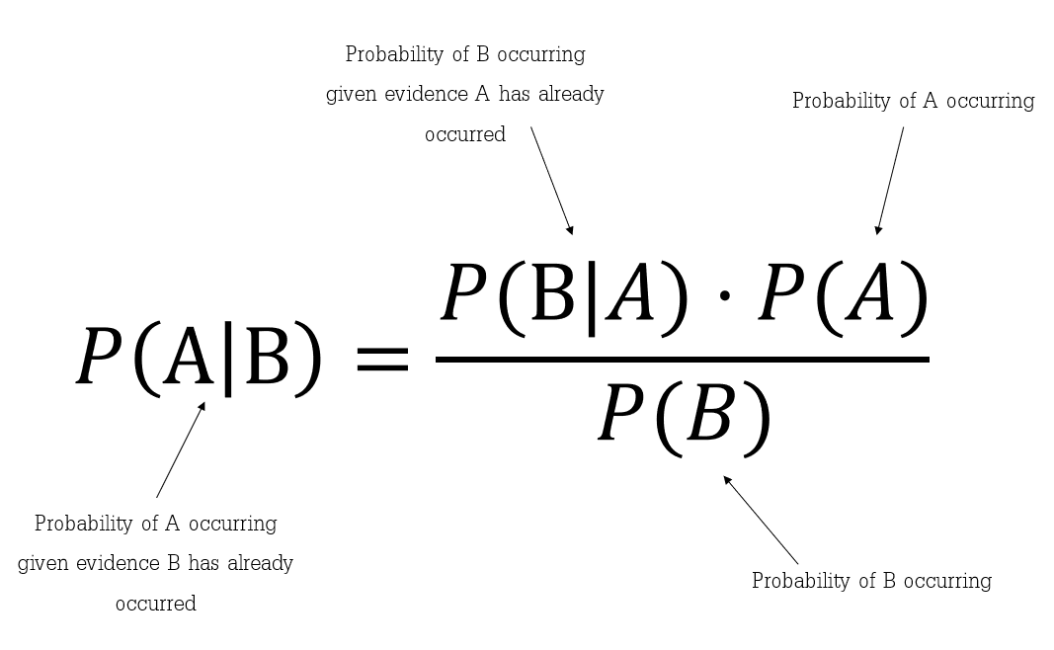

Tree Diagram:
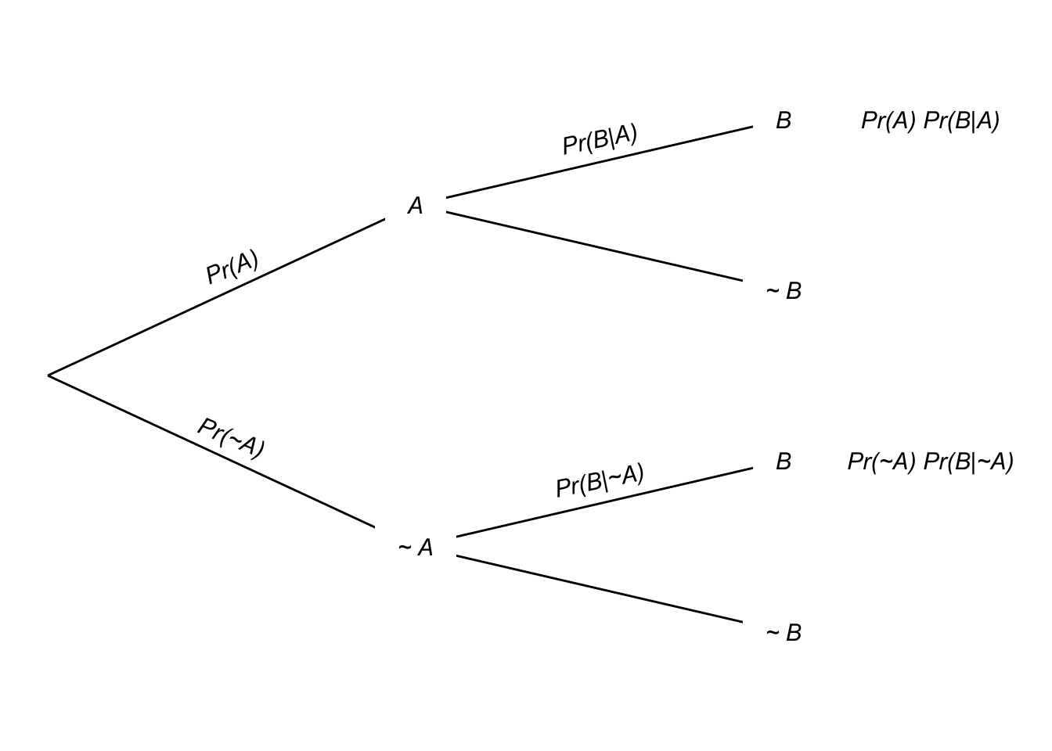

KEY:
- A, B = events
- P(A|B) = probability of A given B is true
- P(B|A) = probability of B given A is true
- P(A), P(B) = the independent probabilities of A and B

Ex 1) A store stocks teddy bears from 3 suppliers. Suppliers A, B, C supply 10%, 30%, and 60% of the stuffed pink bears respectively. 1% of A, 7% of B, and 5% of company C’s bears are defective. If a bear is selected at random and found to be defective, what is the probability that it came from supplier B?

