Unit 4 Study Guide

Matrices
Concepts:
- Basic Operations
- Applications of Basic Operations
- Inverse Matrices
- Solving Systems of Equations (without Matrices)
- Using Matrices to Solve Systems
- Using Matrix Row Operations
Vocabulary:
- Commutative-
  - A+ B= B+A
- Associative-
  - (A+B) + C= A+ (B+A)
- Additive Identity-
  - In a given mathematical system leaves unchanged any element to which it is added.
- Additive Inverse-
  - For a real number, it reverses its sign: the opposite of a positive number is negative, and the opposite to a negative number is positive.
- Square Matrix-
  - A matrix that has the same number of columns and rows
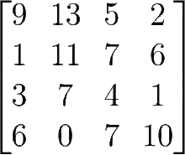

- Identity Matrix-
  - Contains 1 on the main diagonal and 0s elsewhere
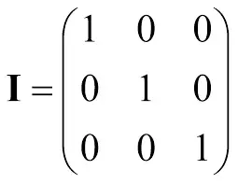
- Scaler Multiplication-
  - to multiply a matrix by a real number,k, multiply each number each number by k
- Determinant-
    - Remember that if the determinant does not equal 0 it has an inverse
- Matrix-
  - A rectangular array of numbers enclosed in a single set of brackets
  - also…
- Dimensions-
  - The description of the shape of a Matrix
  - given row by column
  - 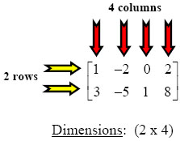
    - Calculator Function:
- Function-2nd x^-1 - 1- Enter your matrix
- 2nd quit- 2nd x^-1- math- 1- 2nd x^-1- 1- Enter to get your answer
- Interpretation-
  - One solution or independent
    - Each x, y, and z have answers and diagonal are 1s.
    - ex: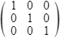
  - Many solutions or dependent
    - Last row is all 0’s
    - ex: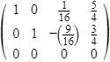
  - No solution or inconsistent
    - Last row is 0 0 0 1
    - ex: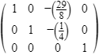

Practice Problems:

4.1 Basic Operations:

- State the dimensions of the matrix.
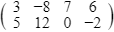

- Identify the indicated element in the following matrix.

A= 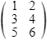 a_{3, 1}

- 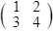+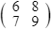

- 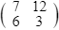-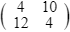

- 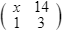+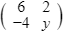

- 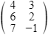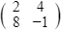

- 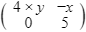

- +

4.2 Applications of Basic Operations

10. The following matrix consists of a shoe store’s inventory of flip flops, clogs, and Mary Janes in sizes small, medium, and large: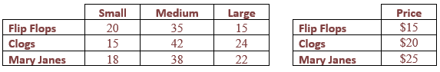
How much their inventory is worth for all the shoes?

11. A nut distributor wants to know the nutritional content of various mixtures of almonds, cashews, and pecans. Her supplier has provided the following nutrition information:
 | Almonds | Cashews | Pecans
Protein (g/cup) | 26.2 | 21 | 10.1
Carbs (g/cup) | 40.2 | 44.8 | 14.3
Fat (g/cup) | 71.9 | 63.5 | 82.8
Her first mixture, a protein blend, consists of 6 cups of almonds, 3 cups of cashews, and 1 cup of pecans. Her second mixture, a low fat mix, consists of 3 cups of almonds, 6 cups of cashews, and 1 cup of pecans. Her third mixture, a low carb mix consists of 3 cups of almonds, 1 cup of cashews, and 6 cups of pecans. Determine the amount of protein, carbs, and fats in a 1 cup serving of each of the mixtures.

4.3 Inverse Matrices and Finding the Determinant
12. Find the determinate and the inverse.
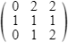

13. Find the determinate and the inverse.
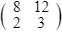

14. Find the determinate and the inverse.
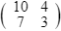

15. Are these inverses? Explain.
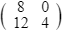 = 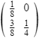

4.4 Examples- Solving Systems with 3 Variables
16. 20x+5y+5z=25
15x+15y-10z=110
5x-10y-5z=15

17. -4y-12z=8
2y+8z=-10
2x+4y+14z=-2

4.5 Using Matrices to Solve Systems

18.
$$4y-z=8x+3$$
Solve $x+12z=2y-3$ if possible, by using a matrix equation. If not possible,
$3y-1=4x+10z$ classify the system.

19. Lydia wants to invest $16,000 in a low-risk investment that earns 7% per year and some of the money a high-risk investment that earns 12% per year. How much money should be invested at each interest rate to earn $1,200 in interest per year?

4.6 Using Augmented Matrices to Solve Systems

20. -1x+2y+2z=15
x+y-2= z
3y-z-18=-2x

21. y= -3x+3z+13
-3x+7z-7y= 6
-2x+2z-6y= 30

