**ICM Unit 5 Review (Functions & Limits)** Name _____________________________ Date ____________

1. Find the limit algebraically.



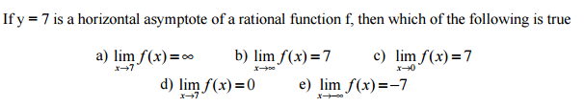



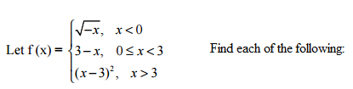



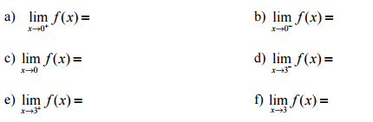

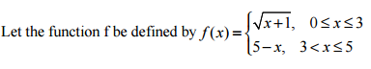





1. 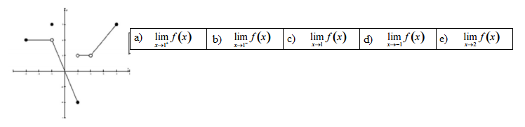Use the graph of f(x) to find each limit.

Find the indicated limit. Which method is most appropriate: Direct Substitution, Numerical, Analytic or Graphical?

1. 
2. 
3. 
4. 
5. 
6. 
7. 
8. 

15. Evaluate each when *f*(x) = x2 – 2x – 3.

a)  b) 

16. Find the average rate of change of $f\left(x\right)=x^{3}-2x+1$ from -3 to -2.

17. For , write the equation of the secant line contain points

(-2, g(-2)) and (1, g(1)).

**State the domain for each of the following. Write answers in interval notation.**

1. 
2. 
3. 
4. 
5. 
6. 
7. 
8. 

**Sketch the graph and state the range of each. Write answers in interval notation.**

1. 
2. 
3. 
4. 
5. 

26. Dana’s cell phone plan costs $42 per month for 1000 minutes (regardless of the time of day).

For each additional minute, she is charged 5¢.

a) Write a function for the cost, *C*, of Dana’s cell phone plan in terms of minutes, *m*.

b) If she spends $60 in March for her cell phone plan, how many minutes will she use?

27. The post office charges $3.00 to mail a package weighing up to (and including) 1 pound and

$0.75 for each additional pound or portion of a pound.

a) Use a step function to write an equation for the total cost C for sending a package weighing x

pounds.

b) Find the cost of mailing a package that costs 3.6 pounds.

c) Graph the function on the domain 0 ≤ x ≤ 8.