Unit 4 and 5: Quadratic Expressions and Equations: Key Concepts

Key Concept 1: Solving Quadratic Equations/Inequalities (Unit 5)
You should be able to…
- Solve a quadratic equation by factoring, graphing, completing the square, or the quadratic formula. (This includes finding complex solutions of the form a $±$bi when the graph has no x-intercepts)
- Solve a quadratic equation by inspection (reverse PEMDAS).
- Use the discriminant to tell the number and type of roots of the quadratic equation.
- Solve a Linear-Quadratic system of equations graphically and algebraically.
- Graph a Quadratic Inequality and name the solutions.

Key Concept 2: Analyzing Quadratic Functions in their different forms (Unit 4)
You should be able to…
- Convert from standard form f(x) = ax² + bx + c to vertex form, f(x)=a(x – h)² + k by completing the square.
- Convert from standard form to factored form by factoring a quadratic function.
- Find x-intercepts, y-intercepts, and max/min of quadratic functions in any form.
1. Solve each quadratic equation.
A. x² - 2x - 24 = 0 B. x² + 1.4x - 15.51 = 0 C. x² + 6x + 16 = 0

D. 3x² + 10 = 4x E. (x -4)² + 9 = 0 F. x² – 10x + 34 = 0

G. x² + 9x = -20 H. x² - 49 = 0 I. 4x² –12x + 9 = 0

2. Convert the given polynomials from standard form to vertex form, then state the vertex. Also determine whether the vertex is a maximum or minimum.
A. f(x) = x² + 8x + 20 B. h(x) = x² – 6x + 5 C. g(x) = -2x² + 12x- 13

3. Consider the functions:
f(x) = 5x² - 13x -15 g(x) = -2(x - 5)² + 7 h(x) = (3x – 4)(x + 8)
A. Which function is in standard form? What is its y-intercept?

B. Which function is in vertex form? What is its maximum?

C. Which function is in factored form? What are its x-intercepts?

Spiral Review Questions
Simplify each polynomial expression.
7. (x+7)(x+1) 8. (2x -4)(3x + 8) 9. (4x -5)²

10. (5x+2)(5x -2) 11. 3(7x²+2x + 1)

12. Factor each polynomial expression.
A. 6x³ – 4x² + 12x B. x² – 144 C. 10 + 50t – 16t²

D. 3x² – 48 E. 16x² – 25 F. x² +10x +21

G. x² – 14x + 45 H. x² + 16x – 17 I. x² – 9x - 36

13. Find the discriminant for the following. Then determine the number and type of zeros.
A.
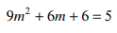
B.
C.
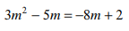
D.

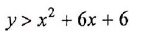
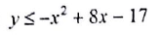
14. Sketch the graph of each function.
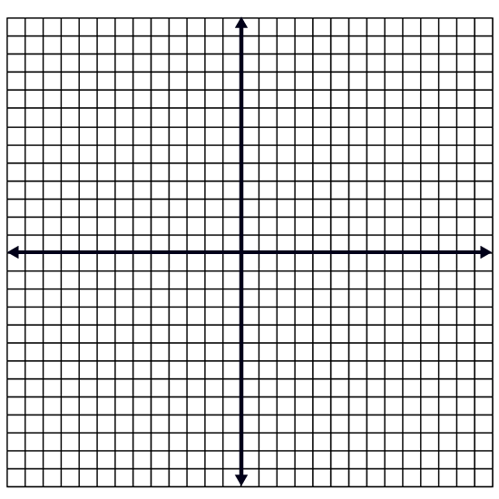
A. B.

15. Find the solutions to the following systems.
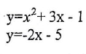
A. Solve by graphing. B. Solve algebraically.
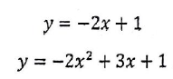

(SOLUTIONS ON NEXT PAGE)

Solutions
1A. x = 6 or x = -4 1B. (-4.7,0) and (3.3, 0) 1C. $x= -3±i\sqrt{7}$
1D. $x=\frac{2±i\sqrt{26}}{3}$ 1E. $x =4±3i$ 1F. $x=5±3i$
1G. x = -4 or x = -5 1H. x = 7 or x= -7 1I. X= 3/2 (double root)
2A. f(x) = (x + 4)² + 4 / minimum at (-4, 4) 2B. h(x) = (x – 3)² – 4 / minimum at (3, -4)
3A. f(x) / y-int: (0, -15) 3B. g(x)/ max: (5,7) 3C. h(x) / x-intercepts: (4/3, 0) and (-8,0)
7. x² + 8x + 7 8. 6x² + 4x – 32
9. 16x² – 40x + 25 10. 25x² – 4 11. 21x² + 6x + 3
12. Factoring Problems
A. 2x(3x² – 2x + 6) B. (x – 12)(x+ 12) C. 2(5 + 25t – 8t²)
D. 3(x – 4)(x + 4) E. (4x – 5)(4x + 5) F. (x + 7)(x + 3)
G. (x – 9)(x – 5) H. (x + 17)(x – 1) I. (x – 12)(x + 3)
13. Discriminant
A. -63; two imaginary solutions B. 0; one real solution C. 16; two rational solutions
D. 33; two irrational solutions
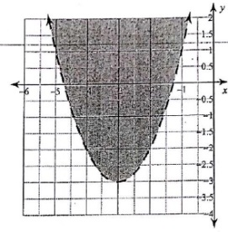
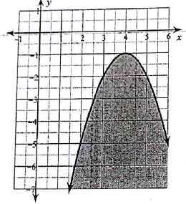
14. Quadratic Inequalities
A. B.

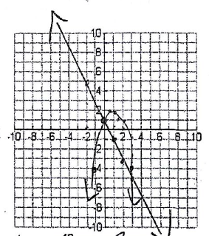
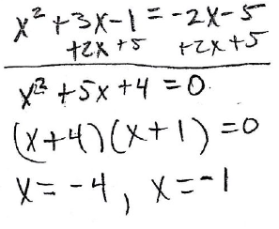
15. Solutions to Systems
A. B.

