**ICM – Unit 6 Review Name ___________________________________________ Date ____________**

You may use this review on your test. You may NOT photo copy anyone else’s or print and glue anything on this review. All answer must be in YOUR handwriting. You will turn in this packet with your test.

**Verify each trig identity.**





2. 







**Use the sum and difference formulas to find the exact value of each. Show work!**

1. tan 75°
2. cos 195°
3. sin $\frac{π}{12}$

**Prove each trig identity.**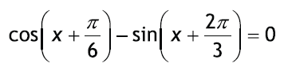



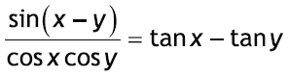



**Prove each trig identity.**



**Solve for the variable on the interval 0 ≤ x < 2π.**

1. 4 cos2 x – 3 = 0
2. cos3 x = cos x
3. 2 sin2 x – sin x – 1 = 0
4. sec2 x – 2 tan x = 4
5. 3 sec2 x – 4 = 0 18. 3 cos x + 3 = 2 sin2 x