**Cholkar MCHS MATH II ___/___/___ Name____________________________**

HW # 1

1. Simplify the following.

|  |  |  |
| --- | --- | --- |
|  |  |  |
|  |  |  |

2. Write each expression in simplest form.

|  |  |
| --- | --- |
|  |  |
|  |  |
|  |  |

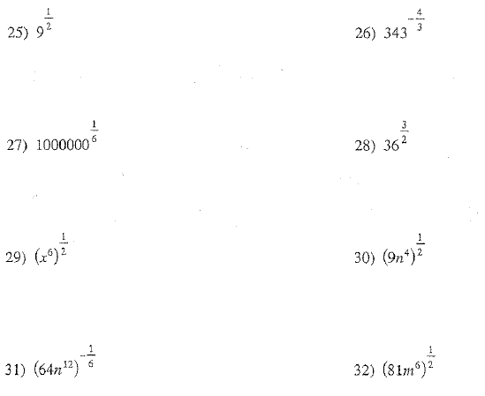1. Simplify the following.

a. b.

c. d.

e. f.

g. h.